

**Haramaya University**

**Chapter one**

**Background of the organization**

Haramaya University is one of the most prominent and prestigious universities in Ethiopia. The University has educated a number of individuals who have contributed to the improvement and development of the world. The University has been the knowledge pool for many other intellectuals, who have made their mission helping human kind and improving our earth.

Haramaya University, formerly known as Alemaya University, was established with the initiative of Emperor Haile Selassie in 1954 based on the need for modernizing Ethiopian agriculture in particular and education in general through the establishment of an agricultural college and training. It was based on the emperor’s wish that the college is founded at its current location. Up until 1963, Oklahoma State University was given the mandate to establish and operate the college. In the past few years the university has witnessed tremendous expansion in terms of fields of study and facilities.

1. **Statement of the problem**

**1.1. Problem Statements**

* **Difficult communication among the campus community**

Since the community are in different place in the campus it take them to call to each other and this is one of the problem with the existing system.

* **Waste time**

If one person wants another person for something it will take much time to contact each other.

* **Waste money**

User will use lot of money to communicate using telephone or hand phone and maybe communication will be discontinues if they do not have sufficient credit.

* **Human power:**

For transformation of information from office to office in the campus human power is needed and this one of the problem there.

.

1. **Objectives**
   1. **General objectives**

To provide chat conversation, easier communication, cheap communication over Haramaya University Local Area Network for communication between student and lecturer or among student and make knowledge sharing between them easier and faster.

**2.2. Specific objective**

* **Text chat conversation**

To provide text Chat over Haramaya University Local Area Network for communication between student and lecturer or among student.

* **Easier Communication**

To make communication on Haramaya University Local Area Network (LAN) among community of university. Student also no need to remember their lecturer telephone numbers. They only need to remember their lecturer name.

* **Quick communication**

To provide the quick communication between student and lecturer without meet each others.

* **Cheaper communication**

TO provide the cheaper communication on LAN as alternative besides using telephone.

* **Knowledge sharing**

To make the knowledge sharing between them easier and faster.

1. **Feasibility study**

To bring the successful completion of this project goals and objectives the feasibilities issues listed below has determined the project viability or the discipline of planning, organizing, and managing resources.

* 1. **Technical Feasibility:**

This involves questions such as whether the most of the technology needed for the system has exists in the Haramaya University (HU) compound. Because the system is too customized according to HU information transferring system there will be no difficulty to build the chatting system, and also the staff and other concerned bodies has or will have enough experience using this system.

* 1. **Operational feasibility**

Currently there is no existing system in the case of chatting system so this system will be implemented in HU as a pioneer of chatting system project. The system will provide adequate through put at desired time to the user and also give the needed information in a timely usefully formatted way. The system also has security to gives access privilege providing account for an authorized person. This system provides help description to the user about how to use the system. And other technical modification on the system is done by the developers.

* 1. **Economic feasibility**

As cost/benefit analysis, show the new system is developed using a very minimum coast and it give a lot of benefits such as advancing the services of the system, decreasing the work load of the users.

1. **Significance of the project**

This LAN text Chat system gives many benefits and can be used byHaramaya University to make the communication among society of the university easy and cheap. It also makes the knowledgesharing between them easier and faster. In Haramaya University already have a lot of computersconnected each others. There only left need is headphone. After this society no needto worry about loses money just to have a communication among them. Using thissystem society can use it to make an appointment with each other.

1. **Beneficiaries of the project**

**Methodology**

* **System development methodologies**

The system analysis methodologies used for developing this system will be Systems Analysis and Design as the area of research because it is a standard procedure for developing a system. The systems development life cycle (SDLC) is an element of Systems Analysis and Design that process of the understanding how an information system can support business needs, designing the systems, building it, and delivering it to users. The systems development life cycle (SDLC) has a five fundamental phases: planning, analysis, design, design (logical and physical) and maintenance.

1. **Planning**

During planning process, the developer required to come out with as many ideas as possible on what the developer going to do, how the developer going to implement it, what the software objectives, who are going to use it and so on. The developer also construct the work plan (milestone) at some stage in this phase to make sure all the datelines can be reached in exact time

1. **Analysis**

The second stage is analysis stage where the developer is requisite to study and evaluate all the existing software with the same objectives within the market. The developer has done a survey to get more information about the software the developer is going to build. What the developer achieved at the end of this phase is that all the information needed including what the problem that the current software encounter, how to fixand enhance it and choose the best alternatives solution for all these problems.

1. **Design**

Followed by the analysis stage is designing stage. This phase can be divided into two sub phases; logical design and physical design. Logical design is functional features described independently. It is more to a rough sketch on a paper on how the flow of the software and all the diagrams are generate in this phase. Physical design is transform logical specifications to technology specific details. All the diagrams constructed are then will be transform to more specific details. The developer found that this is one of the adventurous and risky parts of the project because designing software without facing problems latterly during the implementation phase is not an easy task.

1. **Implementation**

Coding, documentation, training procedures, installation and testing are covered in the fourth phases; implementation phases. This is the most time consuming phases. It needs a lot of courage and commitment. Diagrams and all "formation gathered earlier are now will be use to build the software. This is also one of the toughest phases during the software development. Testing is run many times to make sure all the errors can be detected and debugging process can be initiate.

**Data Collection Methodology**

Methodology we use to collect data required information is interview, reading materials and etc.

* Interview :

We make interview with some society and lecturer in university the importance of text chat LAN on Haramaya University network.

* Reading materials:

Before we plan to develop text chat on LAN we refer some books and read from internet about LAN chat, use of LAN chat and how to develop.

**Development environment**

1. **Uniform Server:**

During developing the project to run and execute programming code on browser by using uniform server local host

.

1. **Dream viewer**

To write and edit programming code and scripts we use dream viewer text editor.

1. **Microsoft office word**

We use Microsoft office during prepare planning and writing documentation.

1. **Microsoft office visio:**

Developed project has some system analysis and design structure and interface like actors, use case and the like. Those are developed by Microsoft office Visio software.

**Programming tools**

* **PHP**

PHP is a programming language expressly designed for use in the distributed environment of the Internet. It was designed to have the "look and feel" of the java language, but it is simpler to use than java and enforces an object-oriented programming model. PHP can be used to create complete applications that may run on a single computer or be distributed among servers and clients in a network. It can also be used to build a small application module or script for use as part of a Web page. PHP scripts make it possible for a Web page user to interact with the page. And it uses during the connection to databases.

***These are some features of Java:-***

* Write software on one platform and run it on practically any other platform
* Create programs to run within a web browser and web services
* Develop server-side applications for online forums, stores, polls, HTML forms processing, and more Combine Java technology-based applications or services to create highly customized applications or services.
* **HTML**

HTML is used to displays text on browsers during execute the program code.

* **JAVA SCRIPT**

Java script is used for textbox validation designed by HTML.

1. **Scope and limitations**

**5.1. scope**

* Developing LAN text chat for Local Area Network (LAN) connection in Haramaya University.
* Haramaya University LAN text chat will be developed using uniform server software to code the PHP, HTML, java script with Mysql database.
* This project will involve all university society in local area network (LAN) connection.
* Modules to develop are Login, Main, Chat room, Chat and Server modules.

**5.2 Limitations**

* May be computer in office, computer laboratory and colleges are not connected to internet or network.
* Compatibility of developed project and exist materials may not match.
* Check………………………………………………………..

**Risks, assumptions and constraints**

**The risks that may face of the project are:**

* Problems malicious programmers such as viruses and worms.
* Lack of materials to test the project at developer level.
* Customization problems if it not recognized with the platforms.
* Lack of requirements at the existing system level.

**Actions to be taken to overcome the above risks**

* Take the backup of data to removable devices to be safe from such danger
* Ask support of department to solve the problems materials
* Discuss with experts and advisors to select compatible platforms.
* Search different website and referance books both online and offline.

**Risks, assumptions and constraints:**

* Haramaya University will have its own chatting system to share information online at a time locally without any internet connection.
* Students and instructors share idea freely online using local chatting system.
* Cost of reduced from the tasks of internet.
* Communication in local chatting is more secure than that of using internet chatting systems ,such as facebook chatting

**List of assumption areas:**

**Project environment:**

All managements will act positively towards the project because there is no such local and secured system previously.

All team members are cooperated and try their best for project to be succeeded.

**Scope of the deliverable:**

Willingness of customers to provide the needed requirements for project development

Consideration of the respondents is needed to success the goal of project as intended.

**Resources**

* Desirable materials are considered to develop and implement the project
* The advice and support of expertise is needed accurately.
* **Constraints**
  + Because of the system is new, the project is challenged to develop the project to developers and lack requirements considering chatting system.
  + Lack of experience to such system when development.

**Material resources**

* PC availability to carry out the project; we have no our own laptop.

**Reduce cost**:

* Because of the system is used locally it’s not more coasted with internet.
* The system is much secured to outside attack.
* Every users of the system must have an account to login into the system.

**Chapter two**

**Business Area Analysis and Requirements Definition**

**Introduction**

The previous chapter is briefly explained the background of an organization, objectives of the project both specifically and generally, statement of the problems, feasibility study and methodology are discussed.

Also Scope and limitations of the project and development environment /programming tool and other tools are mentioned.

In this chapter, the business area of the project is expressed in detail

Major function of existing system is explained in detail and Forms and documents used in the existing system are exposed to be defined.

And the following point is considered:

* Reports generated in the existing system
* Players of the existing system
* Problems of the existing system using the PIECES framework
* Practices to be preserved form the existing system
* Alternative solutions
* Option analysis and the proposed system
* Business Area Analysis and Requirements Definition
* Essential use case modeling
* Essential user interface prototype
* Essential user interface flow diagram will be briefly described

**Major functions of the existing system**

**Existing Chatting System**

In this system the existing chatting systems are those which are used globally with the internet connection. So, Haramaya University is also normally used this systems as other their way of communication concerning chatting on internet connection at online environment. "According to Murray Turoff (1971): we considered the 'chat' function as the minor accomplishment compared to what else we were doing. Today, in terms of usage it is probably the most popular group communication mode on the internet."

There are many different type of chatting system. The chatting systems that will be used as comparison are MSN Messenger, Yahoo Messenger and Face book chatting.

**MSN Messenger**

MSN Instant Messenger is a proprietary instant messaging network by Microsoft. It was released in July 1999 and is either the first or the last instant messaging network. The MSN Instant Messenger protocol is the language used in communication between the client and the server.

MSN Messenger includes a mechanism to allow one client to invite another into an out-of-band session. Invitation is one of the methods that support this part.

Microsoft chose to make the file transfer mechanism subtly incompatible with all other invitation type. Microsoft uses the gateway. Messenger, hotmail.com, uses port 80, as their dispatch server for H17'P (Hyper Text Transfer Protocol) connections. HTTP is most often used for transferring HTML documents.

**Yahoo Messenger**

The yahoo messenger connects to the yahoo server on port 5050. The most difficult part to figure out in the messenger protocol is the login encryption.

The earlier version of the yahoo protocol used the MD5 CRYPT function to do the encryption. This was a pretty weak encryption considering that the encrypted data being sent back to the server was always constant. With version 10 of their protocol yahoo has tried to make the login process more secure.

**Problems of the existing system using the PIECES framework**

* **Performance**

The performance of Haramaya university network with chatting system of internet is slow because of it accessed globally not locally.

When we develop the chatting system locally the speed of accessing the system from local server is very fast compared with global accesses

* **Information:** Information sharing among community of the university is not used local instant messaging system**.**
* **Economy:** To share resource, the existing system used traditional way of communication that consume more time that is the precious resources of the university**.**
* **Control** .The existing system uses the internet connection to share information online. This makes the systems of campus less secure and vulnerable to security threats.
* **Efficiency** The existing system uses the idea sharing methods using internet and phones that have high performance but it is more expensive. Using phone is more expensive that can reduce the organization’s properties. Using internet is expensive and interrupted when internet connection run out it makes the campus out of information.

**Alternative solutions**

* This new system solves the problem of disconnection of internet because it works from local server.
* Staffs shares information and messages without any involvement messengers

**Business Area Analysis and Requirements Definition**

**Requirements Definition**

**Functional requirements**

Functional requirements which are observable tasks or processes that must be performed by the system. For example, functional requirements of my system is must usable and more accessible

for a user in the Haramaya university intranet. The main purpose of the system is to enable users of the systems who use the HU websites collections and to make it accessible using the network

connection and on other storage medias.

**The necessary tasks of system can be:**

* Building the system which will be accessible and transfer information in easy way.
* Enabling the users to make chat in order to contact their friend online in the campus.
* Minimizing the cost and time to share idea among the user.
* Enable the student to know more about the subject they are taking by sharing their idea on question forum available.
* Encouraging the user to give their use the system

***Non functional requirement***

1. **Accessibility**

The accessibility degree of this system can be in two directions. First one is for the administrator who will interact with the system to build the chatting system and the users who will use the system. After the administrator install it in the server or computer he will use it can be accessed easily and friendly without any kind of difficulty. For the users the system is accessible anywhere in the intranet of HU (Haramaya University). It can also be accessed on the internet if it is published by having public domain.

1. **Usability**

The extent to which this system can be used is mainly by HU administrators and by the community of the compound. It is also possible to make it Usable by such organization or institution around the world.

1. **Quality Issues**

To keep the quality of the system when it functions there are basic considerations determined as

requirements for reliability, and user requirement.

**Requirement for reliability**

* Computer with good processing speed, memory and storage capacity for backup.
* Local Area Net work (LAN) and internet connection

**User requirement:**

* Technical issues example user friendly types, layout convention and analysis of the

algorithm.

1. **Security issues**

This issue encompasses measures taken throughout the applications life cycle to prevent exceptions in the security policy of the system through flows in the design, development, and

maintenance of application. In general to make the system asset safe, the system will follow a

role based security which means the access level and privilege for each builders of the system

is predefined by the system administrator. The end user of the system most of the time will be

asked for authorization login except if the user or system developer has set its own criteria

to access the system.

1. **User Interface and human factors**

The developed system provides web application user interfaces that are compatible with internet explorer browsers. For this reason the user of the system especially the developers who develop the system is expected to know at least how to interact with a web application. The users or who navigate the other interface of the system to access the system is also expected to know basic understanding on how to navigate the user interface using a web browser.

1. **Performance characteristics**

The system will be accessed by many users or students inside or outside the university. So it

Should be given more emphasis for the speed to access the website or the system database.

Theconstraint characteristics are also one of the performance characteristics of the system, the constraints can be user’s computer low RAM, Network or connectivity failure, and others.

1. **Error Performance characteristics or handling and Extreme conditions**

When the users of the system interact with the system errors may appear.

To control these inaccuracies the system will generate different messages. Data errors which are entered in to the system may not be completely avoided but they can be minimized. To do this most of the system execution buttons will be controlled according to the sequence which the user is expected to follow. Or this can be done by generating different system responses to the input of the users.

1. **System modification**

Through time there are always changes when the user’s needs another additional functionality, when the system administrator identifies the system need to be modified, while the organizations work style is changed and depending on different reasons. Some of the user interface and basic modification can be performed by the system developers but the system developers are the right persons to update the system.

**Essential use case modeling**

Essential modeling is a fundamental aspect of usage-centered designs -- an approach to software development that is detailed in the book *Software for use*. Essential models are intended to capture the essence of problems through chat system free, idealized, and abstract descriptions. The resulting design models are more flexible, leaving more options open and more readily accommodating changes in chat system technology. Essential models are more robust than concrete representations simply because they are more likely to remain valid in the face of changing requirements and changing the system implementation technology. Essential models of usage highlight *purpose*, what it is that users are trying to accomplish, and why they are doing it. In short, essential models are ideal artifacts to capture the requirements for chat system.

**Use case diagram**

Use Case Diagrams describe what a system does from the viewpoint of an external observer.

The emphasis is on what a system does rather than how.

Use Case Diagrams are closely connected to scenarios. A scenario is an example of what happens when someone interacts with the system.

A use case is a sequence of actions that provide a measurable value to an actor. Another way to look at it is that a use case describes a way in which a real-world actor interacts with the chat system. An essential use-case is a simplified, abstract, generalized use case that captures the intentions of a user in a technology- and implementation-independent manner. An essential use case is a structured narrative, expressed in the language of the application domain and of users, comprising a simplified, generalized, abstract, technology-free and implementation-independent description of one task or interaction. An essential use case is complete, meaningful, and well designed from the point of view of users in some role or roles in relation to a chat system and that embodies the purpose or intentions underlying the interaction.



Our use cases are:

* Sign up
* Login
* Add friend
* Send message
* Control system
* Add system features
* Block friend
* Update profile.

**Actor identification and definition**

**Actor definition**

User

Admin

**Use case description**

**Scenarios** are valuable for providing context to the elicitation of users‟ requirements. They allow the requirements engineer to provide a framework for questions about users‟ tasks by permitting What if?‟ and „how is this done?‟ questions to be asked.

**The Descriptions of Use cases and Scenarios of the Proposed System**

**Sign Up Use Case**

**Name of use case**: **Sign Up** use case

**Participating actor**: user

**Flow of events**:

1. The user logs to **sign up** form the home page of the HU chatting system
2. The user fill sign up form with proper manner
3. The user click on sign up button
4. The system shows success message if he / she fill the form correctly and registered properly and message tries again if not correct.

**Alternative case**:

1. If the registered user exists in the database, the system displays the user name and password already exists message and if the input data has errors the system display error message and allow the user to try again.

**Login Use Case**

**Name of use case**: **Login** use case

**Participating actor**: user

**Flow of events**:

1. The user logs to **Login** form the home page of the HU chatting system
2. The user insert **username** and **password**
3. The user click on **Login** button
4. If the username and password is correct the user enter to his/her profile if not the system display message the username and password you enter is not correct so try again.

**Alternative case**:

1. User sign up to the system

**Add friend Case**

**Name of use case**: **Add friend** case

**Participating actor**: user

**Flow of events**:

1. The user logs to **his or her profile** by her/ his user name
2. The user search friend he / she want to add as friend
3. The user click on **Add Friend** button
4. The searched friend’s friend displayed for the user
5. The system show him or she requesting message as a message is forwarding to that person.
6. The user click on **add friend**

**Alternate case: none**

Update profile Use Case

**Name of use case: Update profile**

**Participating Actor:** user

**Flow of events:**

1. The user logs to his account
2. User click on update profile button on his/ her profile
3. He / she fill the update form.
4. User click update now button.
5. The system displays message successful if the form is correctly updated
6. The user click leaves this page.

**Alternate case:**

1. If the form there is a mistake in the entry the system displays error message and allow making correction

**Exit condition:** The Book record is modified successfully.

Broadcast message to user Use Case

**Name of use case: broadcast**

**Participating Actor:** admin

**Flow of events:**

1. The admin logs to his account
2. User click on broadcast message button
3. Admin write the message
4. Admin click send now button.
5. The system displays message successful
6. The admin click leaves this page.

**Alternate case:**

1. If there is a mistake in the entry the system displays error message and allow making correction

Control system Use Case

**Name of use case: control system**

**Participating Actor:** admin

**Flow of events:**

1. The admin logs to his account
2. User click on control button
3. Admin check functionality of the system
4. If there is the error with the system admin will correct it.
5. The system displays message the system is normal
6. The admin click leaves this page.

**Alternate case: none**

**Essential user interface prototype**

The user interface (UI) is the portion of software with which a user directly interacts. An essential user interface prototype also known as an [**abstract prototype**](http://foruse.com/articles/abstract.htm) or paper prototype is a low-fidelity model, or prototype, of the UI for our system.

It represents the general ideas behind the UI, but not the exact details. Essential UI prototypes represent user interface requirements in a technology independent manner, just as essential use case models do for behavioral requirements. An essential user interface prototype is effectively the initial state ¾ the beginning point ¾ of the user interface prototype for our system. It models user interface requirements, requirements that are evolved through analysis and design to result in the final user interface for our system, enabling you to explore [**usability**](http://www.agilemodeling.com/essays/agileUsability.htm) aspects of our system.

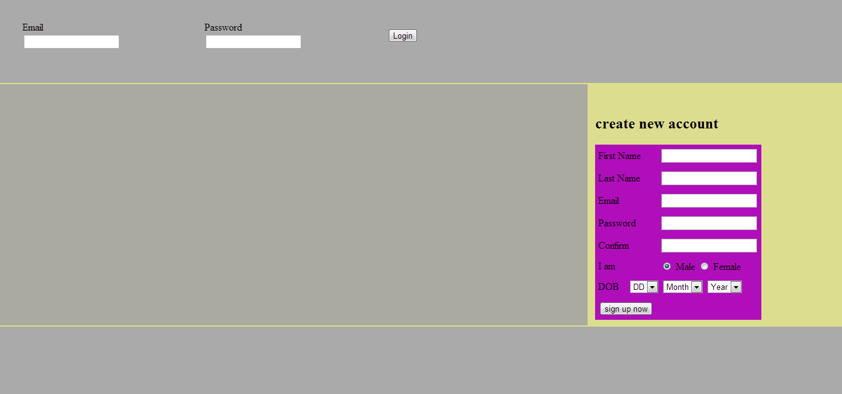

After login to the profile

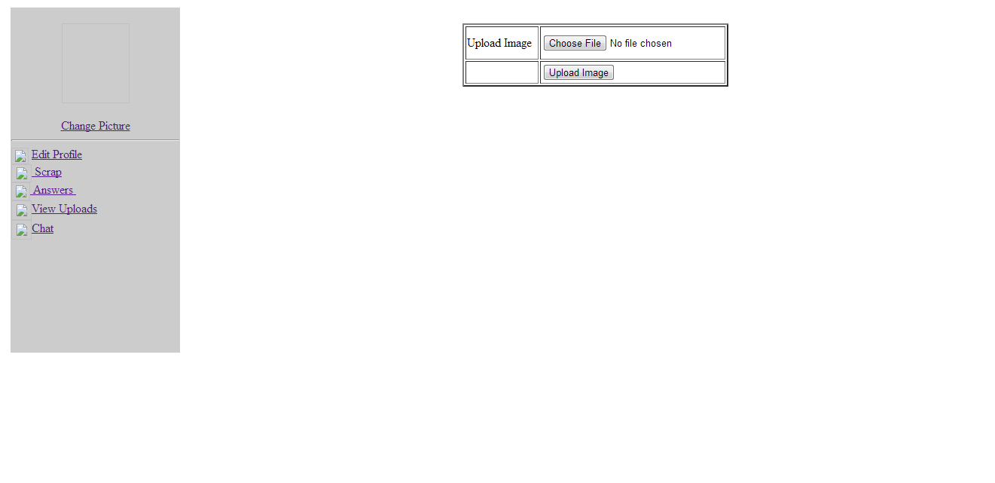

If user want to upload picture

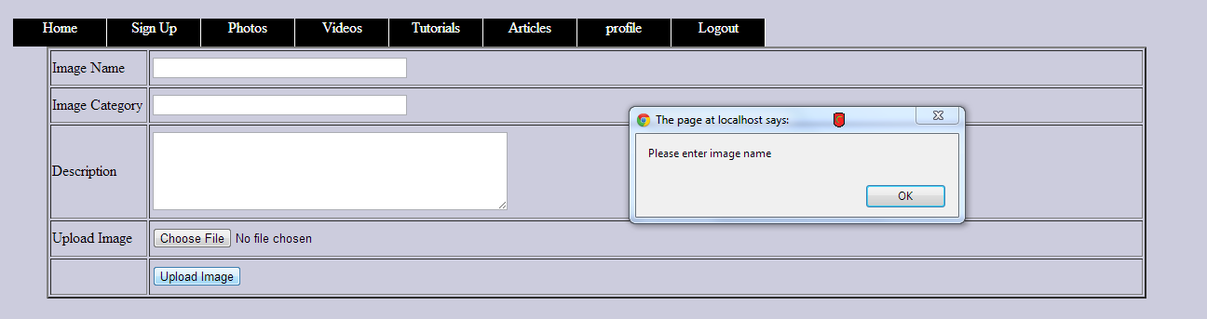

If user wants to upload video

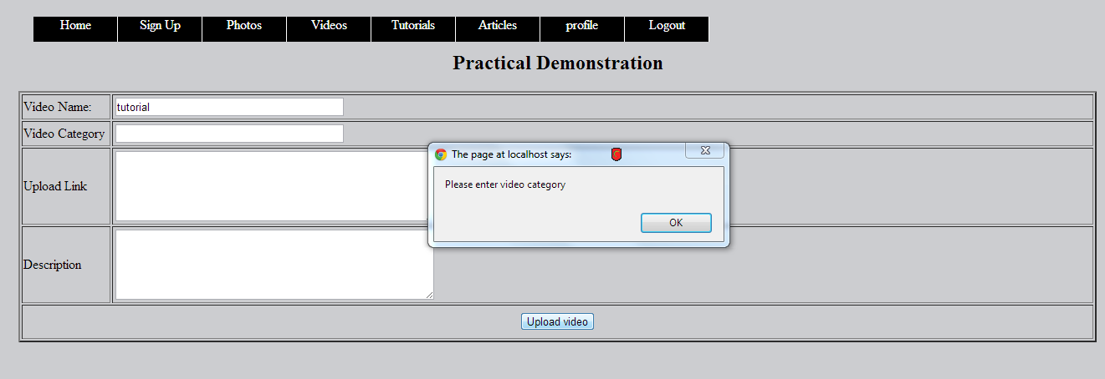

If user wants to view all user on the site

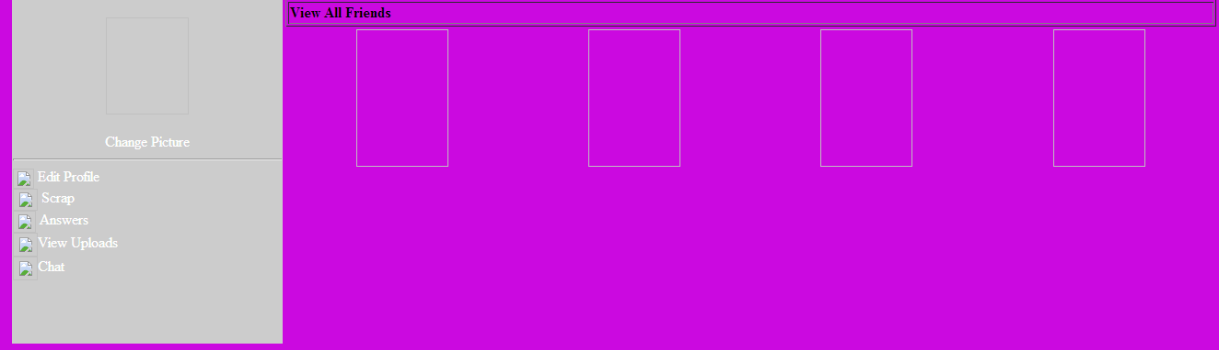

User profile

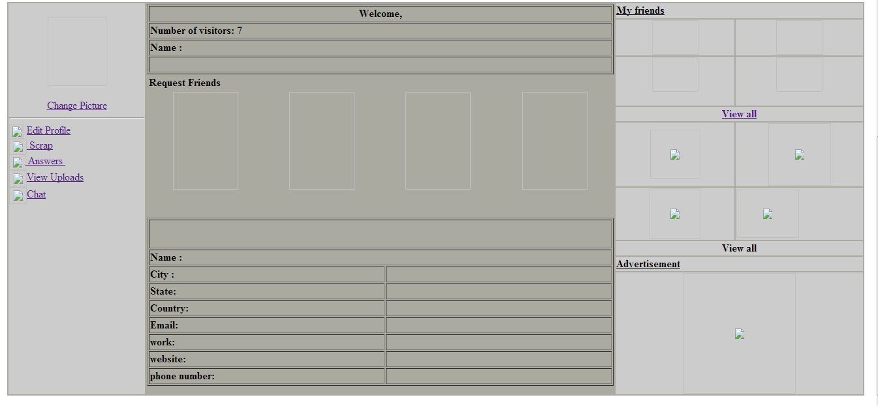

**Essential user inter face flow diagram**

**Definition:**

User interface flow diagram is typically used for one of the two purposes. They are used to model the interaction that users have with our system.



**Lists of user interface**

* Access home page
* Create account
* Login
* Send message
* Add friend
* Modify profile
* Block friend