MODULE TITLE: Leading Small Teams
NOMINAL DURATION: 25 hrs
The module aims to provide the trainees with the knowledge, skills and right attitudes to lead small teams including setting and maintaining team and individual performance standards.
LO1. Providing team leadership
- Introduction to Leading Small Teams

Leadership
Leadership is a process by which a person influences others to accomplish an objective and directs the organization in a way that makes it more cohesive and coherent.
Ie: Leadership is a process whereby an individual influences a group of individuals to achieve a common goal.
- Leaders carry out this process by applying their leadership knowledge and skills.

Traits of a Good Leader
- Honest.
- Competent — Base your actions on reason and moral principles.
- Forward-looking — Set goals and have a vision of the future.
- Inspiring — Display confidence in all that you do.
- Intelligent — Read, study, and seek challenging assignments.
- Fair-minded — Show fair treatment to all people.
- Straightforward — Use sound judgment to make a good decision at the right time.
- Concepts related to team

Team
A team is any group of people organized to work together interdependently and cooperatively to meet the needs of their customers by accomplishing a purpose and goals.
Team members:
- operate with a high degree of interdependence,
- share authority and responsibility for self-management,
- are accountable for the collective performance, and
- Work toward a common goal and shared rewards(s).
- Concepts related to small team leadership
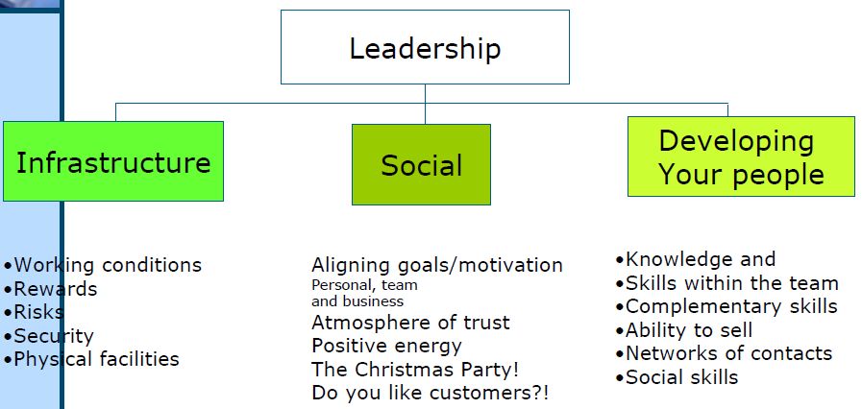

- Conceptualizing performance and responsibilities
Performance is the results of activities of an organization or investment over a given period of time.

Responsibility can be defined as assuming accountability for a task, decision or action. A person is said to be responsible for something when he or she accepts the consequences of something.
- Identifying and presenting work requirements to team members
What are the qualities of good team members?

Characteristics of Good Work Team Members:
1. Honest and Straightforward: A good team member is up front.
2. Shares the Load. A good team member does his or her fair share of the work. There is a sense of equity and
fairness in the good team member.
3. Reliable. The good team member can be counted on.
4. Fair. A good team member takes appropriate credit.
5. Complements Others’ Skills. An important characteristic of effective work teams is the shared capacity.
A good team member provides some unique skills and/or knowledge that move the team forward.
6. Good Communication Skills. Teamwork is social, so good team members need to be skilled, and tactful
(diplomatic), communicators.
7. Positive Attitude.
- Recognizing, discussing, and dealing with team members’ quires(requests) and concerns

What is Recognizing?

To identify a person or thing that is known or experienced before. It may also mean " to accept as valid.
What is Discussion?
A discussion is an oral exploration of a topic, object, concept or experience. All learners need frequent opportunities to generate and share their questions and ideas in small and whole class settings.
Discussing with team member
An effective team leader involves her/his team in setting goals and objectives for the group. The more team members can provide input into defining the objectives, the more they buy into the process and the more committed they are to successfully meeting the objectives.

Identifying, discussing and resolving team members' difficulties
Problems may range from simple to complex. Often, the hardest step is identifying the real issue.
The doctor may ask a patient, 'What's wrong?' The patient describes a range of symptoms and the doctor uses that information, along with their knowledge, skills and observation, to diagnose the problem.
Like a doctor, you may find out the problem in the workplace. You need to carefully note the symptoms, and then use your knowledge and skills to work out what the actual problem is.
Solving a problem involves the following steps:
  - identifying and analyzing the problem
  - Establishing the criteria for solutions/establish the cause of the problem.
  - listing possible solutions
  - exploring and evaluating each possible solution
  - selecting the best solution
  - implementing the decision/solution
  - Evaluating the decision/result of the solution.
LO2. Assigning responsibilities
- Allocating duties and responsibilities to team members by considering the skills, knowledge and attitude required to perform the task according to company policy
Duty is responsibilities to satisfactory perform or complete a task (assigned by someone).
A duty is something that someone is expected or required to do for any number of reasons, including moral or legal obligations.
Example: - A parent has a duty to care for their child.
- A teacher has a duty to educate students.
Responsibility can be defined as assuming accountability for a task, decision or action.
- A person is said to be responsible for something when he or she accepts the consequences of something.
Team members are selected because they have particular skills that are required to complete project tasks. Examples include specialists in business or technical disciplines.
The Team Member’s role is to successfully perform the tasks that have been allocated, keeping the project manager informed of progress as well as any issues that may arise.
Part of the Team Member’s role is to pay attention to the problems others may be facing. Tolerance and good communications are essential ingredients of successful project team members.

Project Team Member’s Responsibilities
The responsibilities assigned to individual team members may vary but typically will include:
- understanding the purpose and objectives of the project
- ensuring a correct balance between project and non-project work
- working to timescales and within cost constraints
- reporting progress against plan
- producing the deliverables/products to agreed specifications
- reviewing key project deliverables/products
- identifying issues
- identifying risks associated with the project
- working together as a team
- contributing towards successful communication
- contributing towards positive motivation
Attitude
Attitude is the view of a person whether positive or negative.
An attitude is a point of view about a situation.
Major components of attitude include:
  - What you feel (Affective): emotions or feelings.
  - Cognitive: belief or opinions held consciously.
  - What you do (Conative): inclination for action.
  - What you think (Evaluative): positive or negative response to stimuli.
LO3. Setting performance expectations for team members
- Describing performance expectations
To perform jobs well, employees need to know what is expected of them. The starting point is an up-to-date job description that describes the essential functions, tasks, and responsibilities of the employees.
Performance Expectations = Results + Actions & Behaviors
To Setting performance standards/expectations
- Review job description for the position
- Determine desirable result or outcome for most of the duties
- Describe what quality performance should look like (communication, customer service, interpersonal skills, etc.)
- Describe how much work must be accomplished within a certain amount of time
- Describe the quality of work to be accomplished (accuracy, document style/format or effectiveness)
- Ensure results are achievable and realistic
- Show how duties relate to BSC’s goals and objectives
- Ensures employee understands that duties are relevant and meaningful
- Explains why particular tasks must be completed in the manner described

Ways of measuring performance expectations/standards
- Direct observation
- Specific work results
- Reports and records
- Commendations or comments received from others
LO4. Supervising team performance
- Monitoring performance against defined criteria
The key to effective monitoring performance is to identify a range of methods – so you can then choose the method that’s easiest to apply and most effective.
In order to ensure that your team are working to the operational plan, you need to monitor performance and the use of resources.
The following can affect performance:
- Environmental change
- Resource usage
- Taking corrective actions
Corrective action is the identification and elimination of the causes of a problem, thus preventing their recurrence.
- Providing feedback (positive support and advice)on strategies to overcome deficiencies
Feedback is giving specific information about a person's current behavior in order to help him/her either continue the behavior or modify the behavior.
Feedback is a Process in which the effect or output of an action is 'returned' (fed-back) to modify the next action. Feedback is essential to the working and survival of all regulatory mechanisms found throughout living and non-living nature, and in man-made systems such as education system and economy.
Purposes
- Provides a basis for maintaining or improving performance
- Provides a forum for assessing need and planning additional experiences

