

**FEDERAL TVET INSTITUTE (FTVETI)**

**Addis Ababa**

**Department of Information and Communication Technology management**

**Chapter -1 Introduction to Database Administration**

1. **Data Base Administration And Administrator**
2. **Need For Database administration**
3. **Database Administrator Functions**
4. **Database Administrator Roles And Responsibilities**
5. **Data Base, Database Administration And Administrator**

Increased awareness of managers that data is an organizational resource has led to a recognized need for disciplined control of all automated and non-automated data. This control is embodied in a set of management procedures and technical functions which is characterized as "database administration".

* **Database:**

"all of the data of the organization which is organized and controlled using a database technology," or "a systematic methodology for the standardization and integration of data resources at an organization level"

* **DBA – Database Administration**

Database administration encompasses all the technical and management activities required for organizing, maintaining and directing the database environment.

A database environment consists of:

* The database, as defined above, including automated and non-automated data;

* The database administrator (DBA) , the manager of the database environment;

* The software tools used in data administration and data processing; and

* The users of the database.

* **Database management system**

a DBMS is a very useful tool for database administration

* **DBA – Database Administrator**

the organization's leader in planning, design, development, implementation, testing, documentation, operation, and maintenance of the entire database environment. The role of the DBA is usually characterized as both technical and administrative.

1. **Need and goal of Database administration**

The main goals of database administration are: to optimize usage of data in a shared database environment; to incorporate a systematic methodology for the centralized management and control of data resources; and to balance conflicting objectives with respect to the organization's mission and the overall economy of data handling. Among the key requirements for effective database administration are: strong management commitment and support; technically competent staff; team participation in the database environment by DBA's, management, technical staff, and users; and a well-defined Database Master Plan. This Master Plan must be developed early, and must include: plans for transition into a database environment, for staffing, and for acquisition of systems and services; definition of responsibilities; and rules and procedures for operation. Significant advantages that database administration can provide are:

* The database can be better managed, especially if the data resources are centralized and shared;

* Data independence can be accomplished via controlled definition, design and implementation of the database;

* Data redundancy and inconsistency can be reduced by balancing conflicting requirements;

* Data integrity can be improved via standard usages, increased data reliability, and enforced security restrictions

* Increased responsiveness to the various user communities can result from better controlled, and more up to-date data; and

* Economic benefits can be derived from elimination of unnecessarily duplicative processing.

The degree to which database administration should be applied depends on the size and complexity of the databases, and the information needs of the overall organization. However, proliferating databases, overlapping requirements, lack of data integrity, and duplication of efforts are symptoms of the need for database administration.

* Data is used by different people, in different departments, for different reasons
* Interpretation and Presentation of data in useful formats
* Distribution of data and information
  + To the right people
  + At the right time
* Data Preservation, Control over Data Usage
* Primary goal: To Support Managerial Decision Making at All Levels of the Organization
  + Top Level 🡪 Strategic Decisions
  + Middle Management 🡪 Tactical Decisions
  + Operational Management 🡪 Daily, Operational Decisions
* DBMS must provide each level a separate view of the data and support their specialized decision making roles

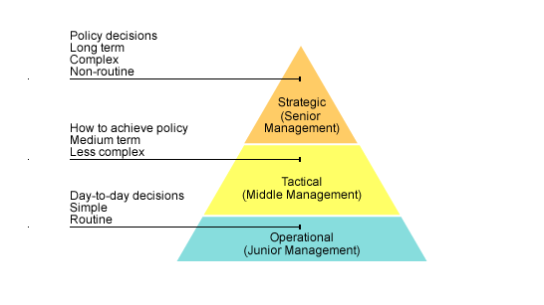

1. **Common Functions of DBA**

**1. Database definition/ redefinition.** The DBA should identify and define common data elements, define the relationships between data elements and other components such as programs, files, and systems. The definition of the data elements and the data relationships should be based on a clear understanding of each participating user community's requirements, as well as the overall organization's needs. Where possible, the DBA uses a data definition language to define and structure the database. It is also in the DBA's purview to define, review and monitor data standards. If the need arises for changing and re-structuring the database, the DBA should initiate this activity, and redefine the database, or any part of it to meet changing requirements.

**2. Selection and procurement** . The DBA should participate in the processes of evaluation, selection, and procurement of hardware, software, and services related to database administration.

**3. Database design/ redesign** . The main design activity is the design and structuring of the entire database, taking into consideration the differing needs of the entire user community. This includes design of the data structure as seen by the application community, the storage structure, mapping and search strategies, and access methods, as well as design of support software for creating, maintaining, and reorganizing the database. If the need arises, redesign and restructuring activities, encompassing all the elements above are also the DBA's responsibilities.

**4. Database creation.** Under this function are included such activities as data collection, database loading and testing, and implementation of data definitions, the other database support software.

**5. Database Security/Integrity** . The database security function is intended to guard against unauthorized access to the database, and unauthorized update, copying, removal or destruction of any part of the database. This may be achieved through the use of security locks and keys, cryptography, etc. Database integrity is related to the DBA's responsibility for the correctness and accuracy of the data. It can be achieved through the use of validation checks, loggings, dumps, backup and recovery procedures , and auditing procedures.

**6. Database maintenance/management.** The DBA should be responsible for the continued well-being of the database environment. As such, it is his responsibility to maintain and update database definitions and database documentation, and to maintain and update the other database support software. The DBA should interpret and administer high level management policies related to the database, and define rules of use and access constraints for the database. In addition, he should be responsible for review, and approval of new data definitions and enforcement of data standards.

**7. Database performance monitoring and evaluation .** Responsibilities should include reviewing, testing , and evaluating the performance of automated as well as procedural data activities; initiation of system improvement when indicated; assessment of the impact of changes; and maintenance of state-of-the-art awareness. If the performance evaluation and monitoring activities indicate that the database is no longer effective or efficient in the present configuration, redefinition, redesign, and restructuring activities may be undertaken .

**8. Database enforcement .** Enforcement activities include determination of compliance with established standard usages; development of database content, organization, and storage control procedures; and responsibility for access control and security of the database, such as password issuance.

**9. Liaison** with users, with systems and application analysts, and with organizational management should provide information, assistance and guidance on the use of database facilities, to detect and correct user problems, and to notify users of changes in system status

**10. Training** of users, staff and management should be coordinated to develop awareness of database concepts, and available resources.

There is another category of functions which is typically performed before the database environment is operational. This category of initiation functions includes such activities as planning, formulating a Database Master Plan, performing feasibility studies, personnel staffing, and negotiating participation in the database environment with different groups of users.

1. **The Database Administrator role and responsibilities**

The DBA, in theory, is the organization's leader in planning, design, development, implementation, testing, documentation, operation, and maintenance of the entire database environment. The role of the DBA is usually characterized as both technical and administrative. There is also a promotional dimension to this role, since the DBA represents the database administration concepts and procedures to all participants, and coordinates all database activities among managers, analysts, systems and application programmers, and users. Because database administration activities impact across organizational boundaries, the DBA position is sensitive, and the DBA must be astute to jurisdictional questions and competing mission requirements. It should be noted that although the tasks in database administration are performed by one or more persons, there is usually one person who is charged with the responsibility for coordinating, controlling and directing activities in the database environment. This person is generally designated as the DBA.

**DBA’s Managerial Role**

* Control and Planning Dimensions of Database Administration
  + Coordinating, Monitoring, and Allocating database administration resources
    - People
    - Data
  + Defining Goals and Formulating Strategic Plans for the Database Administration function

**DBA’s Technical Role**

1. evaluation, selection and installation of DBMS and its utilities,
2. Design and implementation of Database
3. Testing and Evaluation
4. Operation of DBMS, Utilities, and Applications
5. Training and Supporting Users
6. Maintenance of DBMS

**Evaluation, Selection, and Installation**

* Selection of Hardware and Software
* Must be based on the Organization’s Needs
* So the first step is to determine companies NEEDS

**Design and Implementation**

* Determination and Enforcement of Standards and Procedures
* Ensure the Design activities are performed within the Standards and Procedures
* Ensure Transactions are: Correct, Efficient, Compliant with Integrity and Standards
* Physical Design
* Operational Procedures

**Testing and Evaluation**

* All Database and End User Applications
* Maintained Independently of Development and Implementation
* Testing and evaluation cover:
  + Technical Aspects: Backup, Recovery, Security, Integrity, SQL
  + Observance of Standards: Naming, Documentation, Coding
  + Data Duplication Conflicts with existing data

**Operation of DBMS, Utilities, and Applications**

* System Support: Day-to-day activity of the DBMS
* Performance monitoring and tuning
  + Identification of Performance Goals
  + Evaluate if performance Goals are being met
  + Isolate Problems and Find solutions
  + Implement solutions
* Backup and Recovery
* Security auditing and monitoring
  + Appropriate access rights
  + Proper use of access privileges by programmers and end users

**Training and Supporting Users**

* Technical Training in the use of DBMS
* Unscheduled on-demand technical support
* Interaction with DBMS vendors

**Maintenance of DBMS**

* Dedicated to the Preservation of the DBMS environment
* Management of the Storage devices
  + Reorganizing the physical location of the data
* Upgrading the DBMS and Utility Software
* Maintenance is needed when the exchange of data is in dissimilar formats.

**DBA’s Responsibilities**

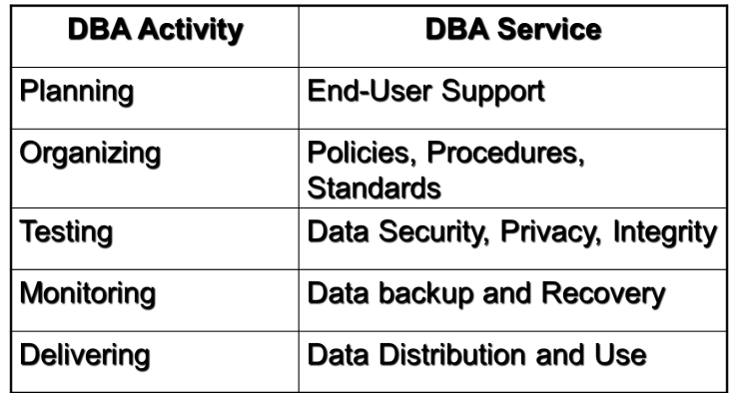

**End-User Support**

* User Requirements Gathering
  + Understanding of the users’ views and needs
  + Present and Future information needs
* Conflict and Problem Resolution
  + Solutions in one department may cause problems in another
* Finding Solutions to Information Needs
* Ensure Quality and Integrity of Applications and Data
* Build End-User Confidence
* Manage the Training and Support of DBMS users

**Policies, Procedures, and Standards**

* Policies: General Statements of Direction or action that communicate and support DBA goals
* Procedures: Written Instructions that describe a services of steps to be followed during the performance of a given activity
* Standards: More detailed and specific than policies, and describe the minimum requirements of a DBA activity
  + Rules that are used to evaluate the quality of the activity

**Areas of Policies and Procedures**

* End-User database requirements gathering
* Database design and modeling
* Documentation and Naming conventions
* Design, coding, and testing of applications
* Database software selection
* Database security and integrity
* Database backup and recovery
* Database maintenance and operation
* End-user training

**Data Security, Privacy and Integrity**

* User Access Management
  + Define each user to the database
  + Assign Passwords
  + Assign Access Privileges
    - Read, Write, Delete
  + Physical Access Control
* View Definitions: Protect and Control the Scope of the Data that is accessible to a user
* DBMS utilities access control: Limit the use of query and reporting tools
* DBMS usage Monitoring: Audit Logs (More difficult in distributed databases)

**Data Backup and Recovery**

* Disaster Management
  + Periodic Data and Application Backups: Full, Incremental, Concurrent
  + Convenient and safe backup storage
  + Physical protection of hardware and software
  + Personal Access Control to the software of a database installation.
  + Insurance Coverage for the data in the database

**Data Distribution and Use**

* Data is only useful when:
  + Given to the Right User
  + Right Time
  + Right Format
* Programmers Deliver programs to access data
  + Time consuming for DBA
* Data Distribution allows end users to access the database
  + Internet
  + Intranets
  + Queries, Web Front Ends
  + End Users may make improper use of database, data duplication, etc.

**Data Dictionary management-**

* Data Elements from all tables of all databases
  + Names, Types, Validation rules, When an Element is Used and by whom
* Defined databases, and properties
* Tables defined in the database
* Indexes defined for each table
* End Users and Administrators
* Programs that access the database
* Access Authorizations for all users
* Relationships among data elements