**Federal TVET Institute**

**Department of Information and Communication Technology**

**Master of Science in ICT Teachers Education**

**ICT547– System and Network Administration**

**Project Assignment (15 %)**

**Student Name 1: Bilal Abadula ID: MTR/074/11**

**Student Name 2: Chalachew Kassaw ID: MTR/081/11**

**Student Name 3: BIRKSAW AYALEW ID: MTR/077/11**

**Student Name 4: ENDALKECHEW ABAGEZA ID: MTR/106/11**

**Student Name 5: Kali Michael Losike ID: MTR/313/11**

1. The **Department of Architectural Technology** is migrating its network by dividing its office and computer lab. Using IP Block of **10.0.160.0/24** perform subnetting and fill up the below table using the desired IP ranges.

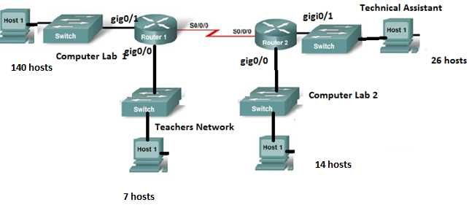

|  |  |  |  |  |  |
| --- | --- | --- | --- | --- | --- |
| **Network** | **Subnet Mask** | **Network Address** | **First IP** | **Last IP** | **Broadcast Address** |
| **Computer Lab 1** | **255.255.255.0** | **10.0.160.0** | **10.0.160.1** | **10.0.160.254** | **10.0.160.255** |
| **Teachers** | **255.255.255.240** | **10.0.161.48** | **10.0.161.49** | **10.0.161.62** | **10.0.161.63** |
| **Computer Lab 2** | **255.255.255.240** | **10.0.161.32** | **10.0.161.33** | **10.0.161.46** | **10.0.161.47** |
| **Technical Assistant** | **255.255.255.224** | **10.0.161.0** | **10.0.161.1** | **10.0.161.30** | **10.0.161.31** |
| **R1 -> R2** | **255.255.255.252** | **10.0.161.64** | **10.0.161.65** | **10.0.161.66** | **10.0.161.67** |

1. **Based on the above subnetting computing and using a Cisco Router or Simulator perform the basic router configuration and connect the two (2) network using RIP version 2 routing protocol. Show the configuration command for each router.**

|  |  |  |  |  |
| --- | --- | --- | --- | --- |
| **Router Name** | **Router Password** | **VTY Password** | **Console Password** | **Banner** |
| **R1** | **Group71** | **Group7v** | **Group7c** | **Waring :access level checked #** |
| **R2** | **Group7r** | **Group7vr** | **Group7cr** | **Router two:cheked security#** |

**After performing the configuration, screenshot and attached in Microsoft Word.**

