**Federal TVET Institute**

**Department of Information and Communication Technology**

**Master of Science in ICT Teachers Education**

**ICT547– System and Network Administration**

**Project Assignment (15 %)**

**Student Name 1: ____________________________________ ID: _______________________**

**Student Name 2: ____________________________________ ID: _______________________**

**Student Name 3: ____________________________________ ID: _______________________**

**Student Name 4: ____________________________________ ID: _______________________**

1. The **Department of Textile Technology** is migrating its network by dividing its office and computer lab. Using IP Block of **10.0.140.0/24** perform subnetting and fill up the below table using the desired IP ranges.

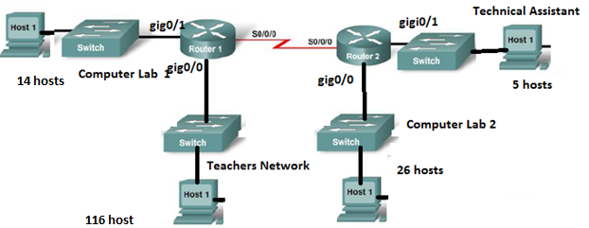

|  |  |  |  |  |  |
| --- | --- | --- | --- | --- | --- |
| **Network** | **Subnet Mask** | **Network Address** | **First IP** | **Last IP** | **Broadcast Address** |
| **Computer Lab 1** |  |  |  |  |  |
| **Teachers** |  |  |  |  |  |
| **Computer Lab 2** |  |  |  |  |  |
| **Technical Assistant** |  |  |  |  |  |
| **R1 -> R2** |  |  |  |  |  |

1. **Based on the above subnetting computing and using a Cisco Router or Simulator perform the basic router configuration and connect the two (2) network using RIP version 2 routing protocol. Show the configuration command for each router.**

|  |  |  |  |  |
| --- | --- | --- | --- | --- |
| **Router Name** | **Router Password** | **VTY Password** | **Console Password** | **Banner** |
|  |  |  |  |  |

**After performing the configuration, screenshot and attached in Microsoft Word.**