|  |  |
| --- | --- |
| **Information Sheet 1** | **Connecting computer to the internet** |

# Connecting PC to the Internet

## Types of connection

## Dialup connection

## Dial-up refers to an Internet connection that is established using a modem.

## When a user initiates a dial-up connection, the modem dials a phone number of an Internet Service Provider ([ISP](http://www.techterms.com/definition/isp)) that is designated to receive dial-up calls.

## Dial up connecting allows you to connect to the internet via a local server using a standard 56k modem.

**Dial up internet connection advantages**

* Very economic and widely available
* Hardware cost are minimal since it uses a standard modem
* Easy configuration
* Convenient for one computer or small network

**Dial up connection disadvantages**

* The slowest connection
  + Since it uses a 56k modem, it transfers 56 kilo bits a second(7 kB) of data
  + The average webpage size is about 50KByte
  + So it takes 7 seconds to load a webpage
* Your telephone line will be busy when connected

**2. Leased connection**

* Use a dedicated line to connect to the internet
* We will have a direct internet connection to the internet
* Always on
* Leased internet connection can be found in many forms the popular two are
  + ADSL
  + Cable

**ADSL connection or (DSL)**

* Stands for “Asymmetric Digital Subscriber Line." It is medium for transferring data over regular phone lines and can be used to connect to the Internet.
* However, like a cable modem, a DSL circuit is much faster than a regular phone connection, even though the wires it uses are copper like a typical phone line.
* An asymmetric DSL (ADSL) connection allows download speeds of up to about 1.5 megabits (not megabytes) per second, and upload speeds of 128 kilobits per second.

To generalize ADSL

* It stands for Asymmetric digital subscriber line
* Uses phone line
* The connections work by splitting your phone line into two separate channels, one for data (internet) and one for voice (phone calls), which means you can talk on the phone and be connected to the internet at the same time.
* Have incredible performance compared to dial up
* Have a flat monthly fee
  + Come in different speeds specification
  + 256Kbps/128Kbps
  + 512Kbps/128Kbps
  + 1Mbps/256Kbps
  + 2Mbps/512Kbps
  + 8Mbps/1024Kbps
* The first number shows the download speed and the second the upload speed

**Advantage of ADSL**

* Always on
* Transfer data and voice at the same time
* Fast

**Disadvantages of ADSL**

* Does not available everywhere
* Additional hardware cost, since it needs a special modem called ADSL modem

**3. Cable connection**

* In [telecommunications](http://en.wikipedia.org/wiki/Telecommunication), cable Internet access, often called simply cable Internet, is a form of [broadband Internet access](http://en.wikipedia.org/wiki/Broadband_Internet_access) that uses the [cable television](http://en.wikipedia.org/wiki/Cable_television) infrastructure.
* It is integrated into the [cable television](http://en.wikipedia.org/wiki/Cable_television) infrastructure analogously to DSL which uses the existing [telephone](http://en.wikipedia.org/wiki/Telephone) network.
* Cable TV networks and telecommunications networks are the two predominant forms of [residential](http://en.wikipedia.org/wiki/Residential_area) Internet access.
* Recently, both have seen increased competition from [fiber deployments](http://en.wikipedia.org/wiki/Fiber-optic_communication), [wireless](http://en.wikipedia.org/wiki/Wireless_broadband), and [mobile](http://en.wikipedia.org/wiki/Mobile_broadband) networks.

Cable connection has the following characteristics

* It uses a separate cable than phone line to transfer data
* Very fast and reliable
* Fixed monthly fee

**Advantage of cable connection**

* Very fast
* Always on
* Doesn’t affect to make/receive a phone call, since it uses a separate cable

**Disadvantages of cable connection**

* Doesn’t available everywhere
* It needs a special modem called cable modem

|  |  |
| --- | --- |
| **Information Sheet 2** | **Troubleshooting the internet** |

# Troubleshooting

The following are some common problems that you might encounter when using the Internet... along with some possible solutions:

### Problem: Can't Connect to the Internet Service Provider ****Solutions:****

* Make sure your modem is switched on and connected to a live phone line.
* Make sure your connection software is configured properly.
* You might be having trouble with your phone line. Before attempting a connection, make sure that all phones on the line are hung up, and check for a dial tone.
* The problem might not be on your end, but might lie with the service provider. Often, if too many users are logged on to a provider's system, the provider will not permit additional connections.

### Problem: Accessing the Web and Other Resources Takes a Long Time Solutions:

* During particularly busy times, your Internet access provider—along with other servers and gateways on the Net—might slow down substantially.
* If your modem speed is slower than 14.4 kbps accessing the more elaborate graphics and other resources on the Web will be difficult, if not impossible.
* Some Internet access providers require that you dial into a special number in order to take advantage of higher speeds (namely 28.8 kbps).
* Most Web browsers allow you to turn off the automatic downloading of graphics when accessing a Web site, thereby speeding access time.
* Sites that rely on plug-in or helper applications, or that contain special features such as Java applets, usually take longer to load than less complex sites.

### Problem: Cannot Access a Particular Web Site: Solutions:

* Web sites are not permanent, and may change URL addresses or even close without notice.
* Some access providers maintain their own archives (caches) of Web sites in order to speed up access. Sometimes, this archiving process will inadvertently disable certain Web functions, making some pages difficult or impossible to access properly.
* Your access provider may maintain firewalls that prevent you from accessing certain Internet resources for security reasons. Contact your service provider if you believe this to be the case.
* A Webmaster may establish bozo filters that block certain users from accessing Web pages. Some bozo filters are temporary, so wait a few days to see if it is removed.
* Your access software may contain a monitoring application that blocks access to Internet resources considered inappropriate for children. Disable this application if necessary; if you need help, ask your service provider.
* If the server containing the site is overloaded or "down," you will not be able to access the site. Try again later.
* Some Web sites require registration before you can access them. Follow the registration procedure (which may require you to pay a fee before full access is granted).

### Problem: Site Loads, But Features Don't Function Properly Solutions:

* The site may contain a Java applet, ActiveX control, JavaScript, or some other advanced feature that your browser cannot process. Make sure that:
  + your browser is capable of using such features, and that
  + These capabilities are activated (see your browser's "Preferences" or "Options" menu).
* Download a newer version of your browser if necessary. Look under "Help" in your browser's menu bar to determine its version.
* Your browser might require a plug-in (auxiliary file)  to use a feature contained in the site. Most sites will provide a link for downloading the necessary plug-in; Microsoft Internet Explorer will attempt to download whatever plug-ins it needs automatically.
* If you are on a slow connection (slower than 28.8 kbps), have a slow CPU, or if you are online at a particularly busy time, your system may have trouble downloading or processing the feature.
* Some "virtual memory" applications, which allow a computer to operate as though it has more RAM than it actually does, can interfere with browsers.
* The site contains non-standard HTML or unusual scripting that is specific to a particular browser.
* The site contains code that is erroneous or corrupt. If you believe this to be the case, notify the Webmaster.

|  |  |
| --- | --- |
| **Operation Sheet 1** | **Connecting computer to the internet** |

### How to use Internet Connection Sharing

#### To use Internet Connection Sharing to share your Internet connection, the host computer must have one network adapter that is configured to connect to the internal network and one network adapter or modem that is configured to connect to the Internet.

#### On the host computer

On the host computer, follow these steps to share the Internet connection:

1. Log on to the host computer as Administrator or as Owner.
2. Click **Start**, and then click **Control Panel**.
3. Click **Network and Internet Connections**.
4. Click **Network Connections**.
5. Right-click the connection that you use to connect to the Internet. For example, if you connect to the Internet by using a modem, right-click the connection that you wants under **Dial-up**.
6. Click **Properties**.
7. Click the **Advanced** tab.
8. Under **Internet Connection Sharing**, select the **Allow other network users to connect through this computer's Internet connection** check box.
9. If you are sharing a dial-up Internet connection, select the **Establish a dial-up connection whenever a computer on my network attempts to access the Internet** check box if you want to permit your computer to automatically connect to the Internet.
10. Click **OK**. You receive the following message:

When Internet Connection Sharing is enabled, your LAN adapter will be set to use IP address 192.168.0.1. Your computer may lose connectivity with other computers on your network. If these other computers have static IP addresses, it is a good idea to set them to obtain their IP addresses automatically. Are you sure you want to enable Internet Connection Sharing?

1. Click Yes.

The connection to the Internet is shared to other computers on the local area network (LAN). The network adapter that is connected to the LAN is configured with a static IP address of 192.168.0.1 and a subnet mask of 255.255.255.0

**On the client computer**

To connect to the Internet by using the shared connection, you must confirm the LAN adapter IP configuration, and then configure the client computer. To confirm the LAN adapter IP configuration, follow these steps:

1. Log on to the client computer as Administrator or as Owner.
2. Click **Start**, and then click **Control Panel**.
3. Click **Network and Internet Connections**.
4. Click **Network Connections**.
5. Right-click **Local Area Connection**, and then click **Properties**.
6. Click the **General** tab, click **Internet Protocol (TCP/IP)** in the **This connection uses the following items**list, and then click **Properties**.
7. In the **Internet Protocol (TCP/IP) Properties** dialog box, click **Obtain an IP address automatically** (if it is not already selected), and then click **OK**.  
     
   **Note** You can also assign a unique static IP address in the range of 192.168.0.2 to 192.168.0.254. For example, you can assign the following static IP address, subnet mask, and default gateway:
8. IP Address 192.168.0.2
9. Subnet mask 255.255.255.0
10. Default gateway 192.168.0.1
11. In the **Local Area Connection Properties** dialog box, click **OK**.
12. Quit Control Panel.

To configure the client computer to use the shared Internet connection, follow these steps:

1. Click **Start**, and then click **Control Panel**.
2. Click **Network and Internet Connections**.
3. Click **Internet Options**.
4. In the **Internet Properties** dialog box, click the **Connections** tab.
5. Click the **Setup** button.  
     
   The New Connection Wizard starts.
6. On the **Welcome to the New Connection Wizard** page, click **Next**.
7. Click **Connect to the Internet**, and then click **Next**.
8. Click **Set up my connection manually**, and then click **Next**.
9. Click **Connect using a broadband connection that is always on**, and then click **Next**.
10. On the **Completing the New Connection Wizard** page, click **Finish**.
11. Quit Control Panel.

When you now start Microsoft Internet Explorer, the client computer will try to connect to the Internet by using the host computer's shared Internet connection.

### Troubleshooting

When you turn on Internet Connection Sharing on the host computer, the host computer's LAN adapter is automatically assigned the IP address of 192.168.0.1. Therefore, one of the following situations may occur:

* **IP address conflict**  
  Each computer on the LAN must have a unique IP address. If more than one computer has the same IP address, an IP conflict occurs, and one of the network adapters turns off until the conflict is resolved. To resolve this conflict, configure the client computer to automatically obtain an IP address, or assign it a unique IP address.
* **Loss of network connectivity**  
  If your network is configured with a different IP address range than Internet Connection Sharing uses, you will lose network connectivity with the host computer. To resolve this issue, configure the client computers to automatically obtain an IP address, or assign each client computer a unique IP address in the range of 192.168.0.2 to 192.168.0.254.

**Connecting to the internet using DSL in Windows 7**

* From the **Start** menu, choose **Control Panel**.

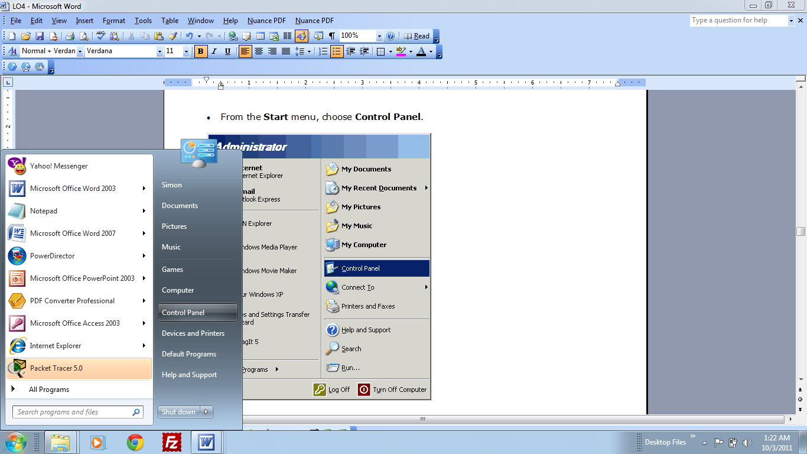

* On the **Control Panel**, click on **Connect to the Internet** on the Network and Internet.

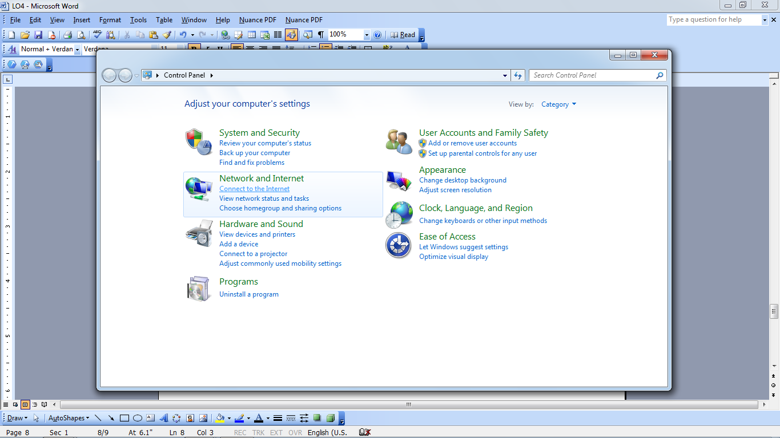

* A dialog box will appear asking if “Do you want to use a connection that you already have?
* Choose **No, create a new connection**.

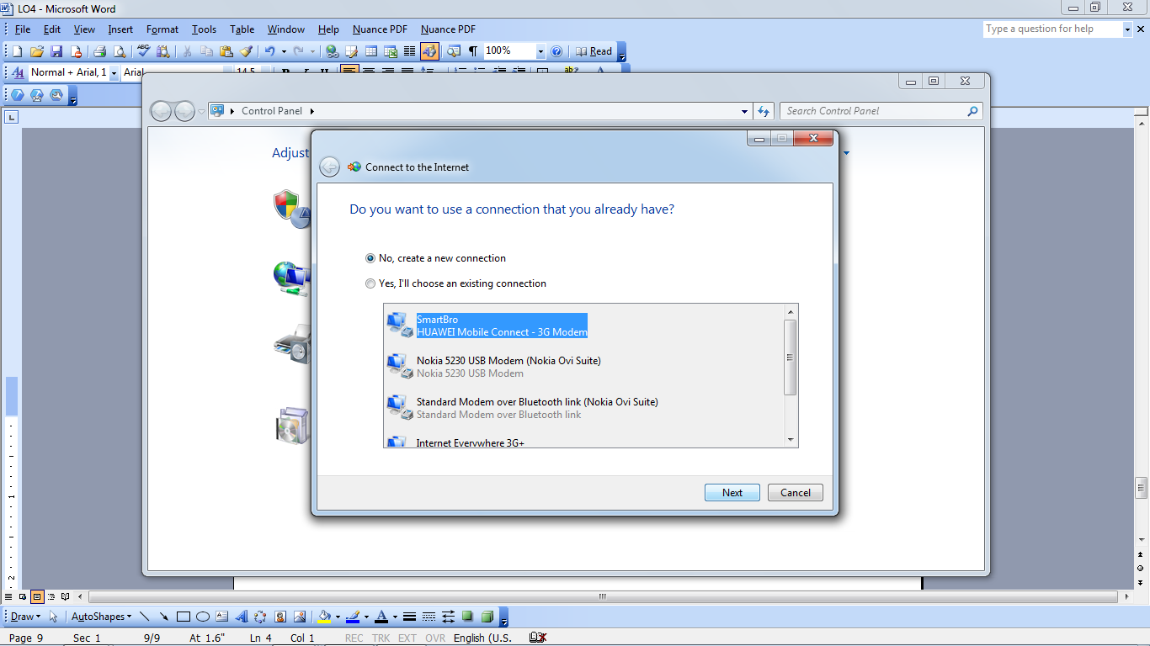

* Then click **next button**.
* It will again prompt you on **How do you want to connect?**

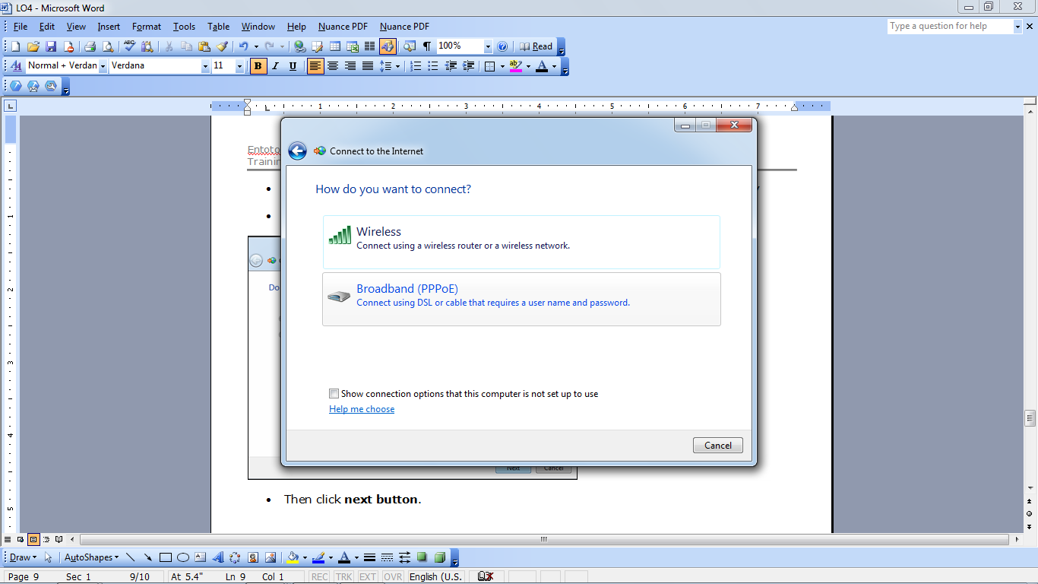

* Clickon **Broadband (PPPoE)**

Connect using DSL or cable that require a user name and password.

* Type the **username** and **password** that your internet provider gave you
* Then type what **broadband connection name** you want for your DSL connection

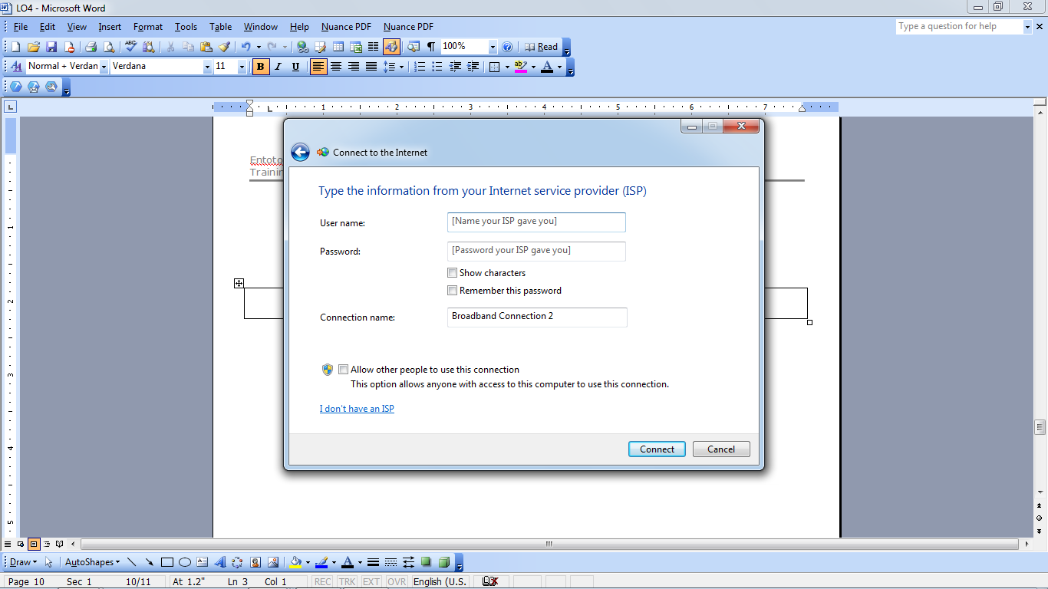

* Then click **Connect.**
* You have just set-up a DSL connection. You can now start browsing the web using any of the internet browser. You may any of the common browser like Internet Explorer or Mozilla Firefox.
* To launch it, click on the **start menu** then click **Internet explorer**

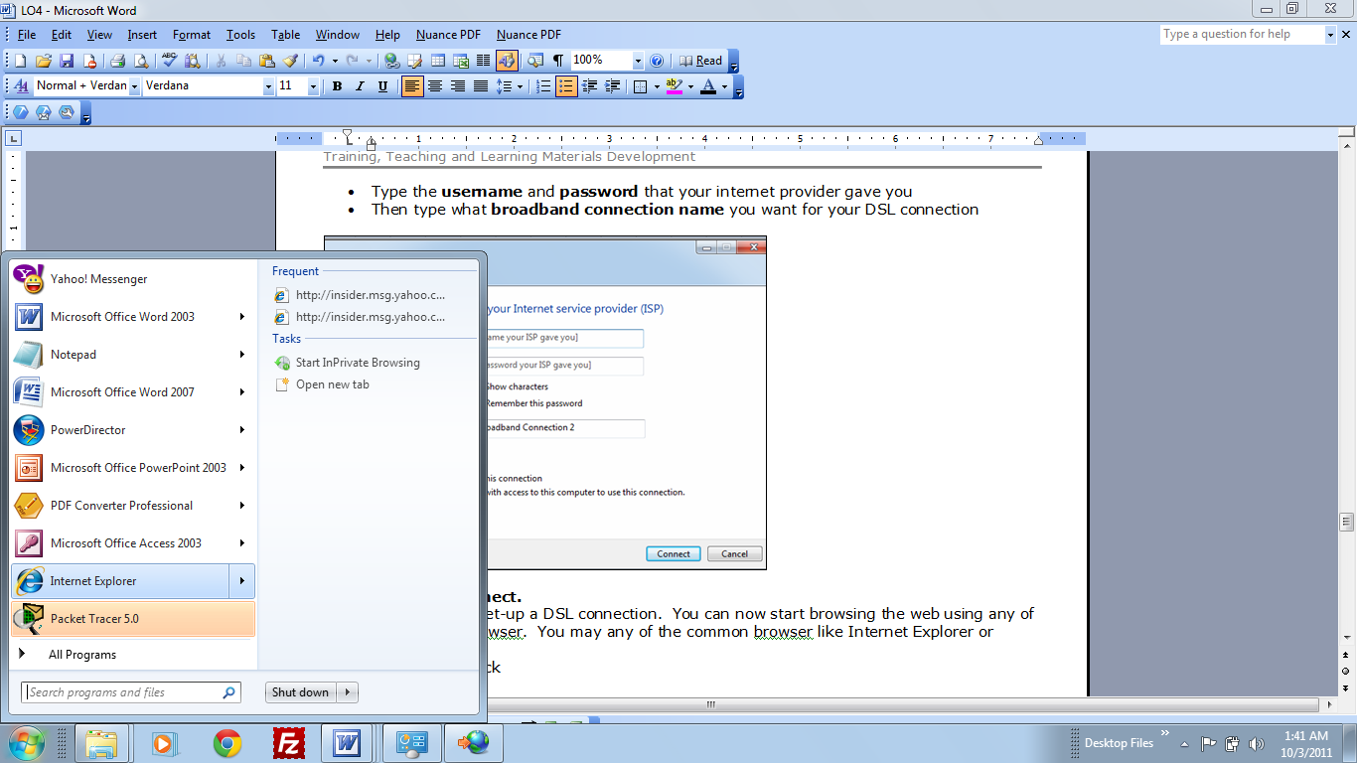

* You are now ready to browse the web

