# Introduction to Computer Hardware peripherals

***Definitions of computer peripherals***

* External devices which are attached to the external part of the computer
* Any device connected internally or externally to a computer and used in the transfer of data
* Any input, output or storage device connected externally or internally to the computer's CPU, such as a monitor, keyboard, printer, disk, tape, graphics tablet, scanner, joy stick, paddle or mouse.

***Device driver***

* It is a small program that tells the computer how to communicate with input/output (peripheral) devices.
* Every peripheral device needs device driver to communicate with the computer system.

**Computer peripherals were grouped into several categories**: The Input Devices, The Output Devices, the Processors, and The Storage Devices.

***The Input device***

***Define peripheral Input devices***

An input device is any device that provides input to a computer. There are many input devices, but the two most common ones are a keyboard and mouse.

1. ***Keyboard***

* The computer key board is used to input, or enter, letters, numbers, symbols, punctuations and commands into the computer.
* 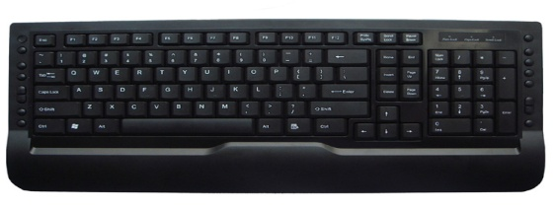The standard keyboard layout is sometimes called QWERTY layout and it is the most common layout.

***Types of Keyboard***

1. **101-Key Enhanced Keyboards**

* IBM introduced this keyboard in 1986 as part of the IBM PC/AT Model 339.
* Enhanced keyboards with 101 keys are also used today.

The major changes that were introduced in the keyboard layout were:

* Additional Ctrl and Alt keys.
* Extra keys in the numeric keypad - Introduced the Enter and / keys.
* Additional function keys: - Featured the F11 and F12 keys.
* Movement of function keys: - In the previous version, the function keys were on the left of the keyboard. In this version, the function keys were shifted to the top.
* Separate Cursor and navigation keys: - Introduced dedicated cursor and navigation keys for the first time. The previous version of the keyboard had the cursor keys as part of the numeric keypad.
* Movement of Esc and Caps Lock keys

1. **102-key Enhanced keyboards**

* These keyboards were introduced to make the usage of keyboards easier for non-English users.
* There are several versions of this layout.
* There are almost identical to the 101-key enhanced keyboard.

1. **104-key windows keyboard**

* Windows keyboard as an improvement over the 101-key enhanced keyboard.
* These two keyboards are almost identical.
* Windows keyboard only had an addition of three special keys that initiated Windows related functions.
* These two keys (Start menu and right-click).

***How keyboard works***

* The keys are arranged in rows and columns.
* When a key is pressed, a *unique row-and-column signal is generated* and sent to the keyboard interface IC on the keyboard.
* The keyboard interface then converts the row-and-column signal into single byte code called a *Key code* or *scan code*.
* When the key is released, a second signal is sent to the keyboard interface IC, which generates a *break code*.
* The keyboard interface IC then *sends* the *scan codes* by means of serial connection through the keyboard interface to the computer.
* The keyboard controller, located on the motherboard, *converts* the *signals* to parallel *data.*

1. ***Mouse***

* Mouse is any human interface device that allows a user to input spatial data to a computer.
* A [device](http://www.webopedia.com/TERM/D/device.html) that controls the movement of the [cursor](http://www.webopedia.com/TERM/C/cursor.html) or [pointer](http://www.webopedia.com/TERM/P/pointer.html) on a [display screen](http://www.webopedia.com/TERM/D/display_screen.html).
* A mouse is a small [object](http://www.webopedia.com/TERM/O/object.html) you can roll along a hard, flat surface.
* Mouse contain at least two [button](http://www.webopedia.com/TERM/B/button.html) and sometimes as many as three, which have different functions depending on what [program](http://www.webopedia.com/TERM/P/program.html) is [running](http://www.webopedia.com/TERM/R/run.html).
* Some newer mice also include a *scroll wheel* for scrolling through long documents.

***Types of mouse***

1. **Optmechanical mouse**

* The *optical-mechanical* or *Optomechanical* mouse consists of a ball that rolls one of two wheels inside the mouse.

1. **Optical mouse**

* Computer [mouse](http://www.computerhope.com/jargon/m/mouse.htm) that utilizes light-emitting diodes ([LED](http://www.computerhope.com/jargon/l/led.htm)) or laser as a method of tracking movement.
* This mouse is much more accurate than the ordinary optical mechanical mouse.
* One drawback to an optical mouse is they can have problems in bright lights.
* The Optical is a much better solution for a computer mouse.

1. **Scanner**

* Scanner is a device that can scan or digitize images on paper and convert them to data that the computer can use.
* They can then be stored in a file, displayed on the screen, added to documents, or manipulated.

***Other input devices***

* Input devices, such as buttons and joysticks, can be combined on a single physical device that could be thought of as a composite device.
* [Game controller](http://en.wikipedia.org/wiki/Game_controller)
* [Gamepad](http://en.wikipedia.org/wiki/Gamepad) (or joy pad)
* [Paddle (game controller)](http://en.wikipedia.org/wiki/Paddle_(game_controller))

***Image and Video Input device***

* Video input devices are used to digitize images or video from the outside world into the computer.
* The information can be stored in a multitude of formats depending on the user's requirement.
* **E.g.** [digital camera](http://en.wikipedia.org/wiki/Digital_camera), [Webcam](http://en.wikipedia.org/wiki/Webcam), Image scanner, [Fingerprint scanner](http://en.wikipedia.org/wiki/Fingerprint_scanner) and etc...

***Medical Imaging***

* E.g. computed tomography, [Magnetic resonance imaging](http://en.wikipedia.org/wiki/Magnetic_resonance_imaging), [Positron emission, tomography](http://en.wikipedia.org/wiki/Positron_emission_tomography) and etc...

***Audio input device***

* Audio devices are used to either capture or create sound.
* In some cases, an audio output device can be used as an input device.
* E.g. Microphone, MIDI keyboard or other digital musical instrument

***The Output Device***

***Define peripheral Output devices***

Any device that outputs information from a computer is called, an output device.

***Monitor***

* The monitor, which connects to the video card, is the computer’s primary output device. It is sometimes referred to as a display, Screen, Visual display Terminal or video.
* Like television, the size of the monitor is measured diagonally across the screen. The most popular size for monitors are 14”, 15”, 17’’, and 21”

***Type of monitor***

There two of type of monitor:

***Cathode ray tube (CRT)***

Traditional computer monitors and televisions. The image on a CRT display is created by firing electrons from the back of the tube to phosphors located towards the front of the display.

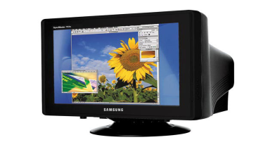The color you see on the screen is produced by a blend of red, blue, and green light, often referred to as [RGB](http://www.techterms.com/definition/rgb).

Cathode ray tube monitor

***Liquid crystal display (LCD)***

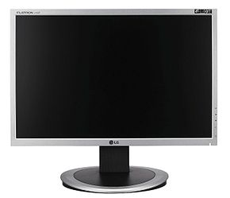Stands for "Liquid Crystal Display." LCDs are super-thin displays that are used in laptop computer screens and flat panel monitors. Smaller LCDs are used in handheld TVs, PDAs, and portable video game devices.

Liquid crystal display

## Printers

A printer is an [output device](http://www.techterms.com/definition/outputdevice) that prints paper documents. This includes text documents, images, or a combination of both.

## Type of Printers

## Ink jet printer

* Inkjet printers are the most common type of consumer printers. The inkjet technology works by spraying very fine drops of ink on a sheet of paper.
* Ink-jet printers are excellent to print graphs, charts, drawings and diagrams.

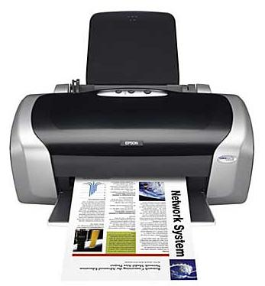

Ink-jet printer

## Dot-matrix printer

* A dot matrix is a 2D matrix of dots that can represent images, symbols, or [characters](http://www.techterms.com/definition/character).
* These printers are cheap and relatively fast but they are noisy and they do not produce high quality output.

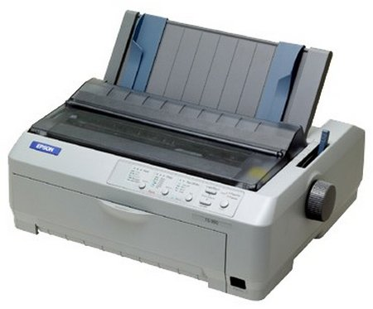

Dot-Matrix printer

## Laser printers

* Laser printers work similarly to a copying machine by converting data from the computer into a beam of light.
* 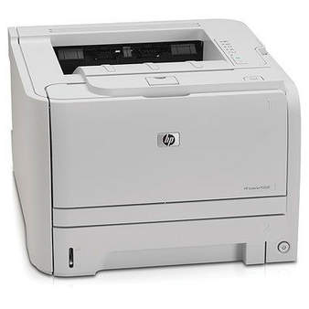Laser printers are the best and the most expensive printer. They are fast in printing and have high quality print output.

Laser printers

## The Processor

* Stands for "Central Processing Unit." This is the pretty much the brain of your computer.
* It processes everything from basic instructions to complex functions.
* Any time something needs to be computed, it gets sent to the CPU.

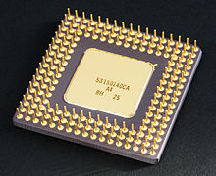

Central processing unit (CPU)

**E.g.** Pentium 4, Core Duo, Dual Core, Core i3, Core i5, Corei7

## CPU Components

Centeral Prosesing Unit can be divaded into Three parts.

**Arithmetic logic unit** (**ALU**)**:**

* Is a [digital circuit](http://en.wikipedia.org/wiki/Digital_circuit) that performs [arithmetic](http://en.wikipedia.org/wiki/Arithmetic) and [logical](http://en.wikipedia.org/wiki/Logical) operations.
* Arithmetic instructions include addition, subtraction and shifting operations.
* while logic instructions include [boolean](http://www.techterms.com/definition/boolean) comparisons, such as AND, OR, XOR, and NOT operations.

**Control unit (CU)**

* control unit (CU), which extracts instructions from memory and decodes and executes them, calling on the ALU when necessary.

**Registray**

* Registray is a small amount of [storage](http://en.wikipedia.org/wiki/Computer_storage) available as part of a [CPU](http://en.wikipedia.org/wiki/CPU) or other digital processor.
* load data from a larger memory into registers where it is used for arithmetic, manipulated, or tested, by CPU.

## The Storage devices

* Computer data storage, often called storage or memory.
* A computer storage device is any type of hardware that stores data.
* The most common type of storage device, which nearly all computers have, is a [hard drive](http://www.techterms.com/definition/harddrive).
* The computer's primary hard drive stores the operating system, applications, and files and folders for users of the computer.
* There are olse several storage divase like Flash Dick, CD Disk, DVD Disk and ets.
* There are 3 types of storage devices

1. **Primary Storage devices:**

* is also known as the main memory or a temporary storage device.
* According to other media it is fast in nature but can accommodate only few data.
* Those are Randam access memory and Read only memory

**Random Access Memory (RAM):**

* RAM is made up of small memory chips that form a [memory module](http://www.techterms.com/definition/memorymodule).
* These modules are installed in the RAM slots on the [motherboard](http://www.techterms.com/definition/motherboard) of your computer.
* Every time you open a [program](http://www.techterms.com/definition/program), it gets loaded from the [hard drive](http://www.techterms.com/definition/harddrive) into the RAM.
* This is because reading data from the RAM is much faster than reading data from the hard drive.
* The more RAM your computer has, the more data can be loaded from the hard drive into the RAM, which can effectively speed up your computer.
* It is volatil memory.

[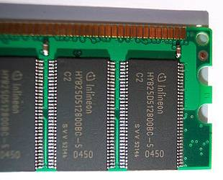](http://en.wikipedia.org/wiki/Input/output)

Random access memory (RAM)

**Read only memory (ROM):**

* ROM is memory containing hardwired instructions that the computer uses when it boots up, before the system software loads.
* 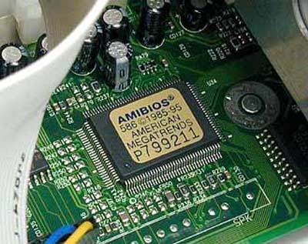In PCs, the instructions are read from a small program in the ROM, called the BIOS (Basic Input/Output System).

Read Only Memory(ROM)

1. **Secondary Storage – Secondary storage:**

* also known as external memory or auxiliary storage, differs from primary storage in that it is not directly accessible by the CPU.
* Secondary storage does not lose the data when the device is powered down—it is non-volatile.
* The computer usually uses its [input/output](http://en.wikipedia.org/wiki/Input/output) channels to access secondary storage and transfers the desired data using [intermediate area](http://en.wikipedia.org/wiki/Data_buffer) in primary storage.
* E.g. Internal Hard drive, external Hard Drive, Flash Disk, CD/DVD, Floppy disk, Memory card*.*

**Hard Drive:**

* The hard drive is whech stores all your data on the computer system permanently.
* It houses the hard disk, where all your files and folders are physically located.
* The data is stored on a stack of disks that are mounted inside a solid encasement.
* These disks spin extremely fast so that data can be accessed immediately from anywhere on the drive.
* The data is stored on the hard drive magnetically, so it stays on the drive even after the power supply is turned off.
* 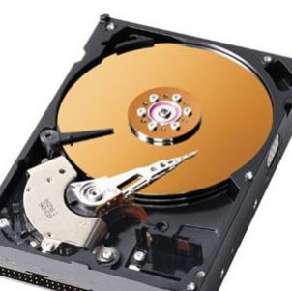The term "hard drive" is actually short for "hard disk drive." The term "hard disk" refers to the actual disks inside the drive.

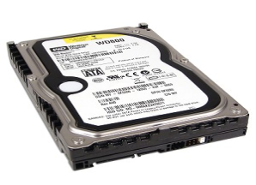

Hard Drive or Hard Disk

**CD (Compact disk):**

* The CD standard was proposed by Sony and Philips in 1980 and the technology was introduced to the U.S. Market in 1983.
* CDs can hold up to 700 MB of data or 80 minutes of audio.
* The data on a CD is stored as small notches on the disc and is read by a laser from an optical drive.
* The drives translate the notches (which represent 1's and 0's) into usable data.
* Accesed by CD-ROM

**DVD (Digital Vidio Disk):**

* Stands for "Digital Versatile Disc." It can also stand for "Digital Video Disc," but with the mulitple uses of DVDs, the term "Digital Versatile Disc" is more correct.
* A DVD is a high-capacity optical disc that looks like a CD, but can store much more information.
* While a CD can store 650 to 700 MB of data, a single-layer, single-sided DVD can store 4.7 GB of data.
* The advanced DVD formats are even more amazing. There is a two-layer standard that doubles the single-sided capacity to 8.5 GB.
* Accesed by DVD-ROM.

1. **Tertiary Storage**

* Tertiary storage or tertiary memory provides a third level of storage.
* computer storage devices, usually consisting of magnetic tape transports and mass storage tape systems, which have slower access times, larger capacity, and lower cost than main storage or secondary storage.

## Connectivity devices

* The majority of external peripheral devices connect to the back of the computer’s system unit with cables.
* The computer’s system unit has a variety of ports available for use by different peripheral device cables.
* A port is a socket that is used to connect the cables from peripheral devices to the computer.
* Computer connectivity devices were grouped into several categories:

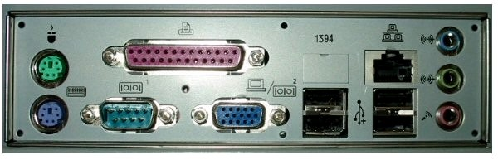**Ports:**

Ports at the back of a computer

There exist several types of ports like serial port, parallel port, USB port, Expansion port, power supply port

**serial port:**

* The serial port is a type of connection on PCs that is used for peripherals such as mice, gaming controllers, modems, and older printers.
* There are two types of serial ports -- DB9 and DB25. DB9 is a 9-pin connection, and DB25 is, you guessed it, a 25-pin connection.
* A serial port can only transmit one bit of data at a time, whereas a parallel port can transmit many bits at once.
* The serial port is typically the slowest port you'll find on a PC, if you find one at all.
* 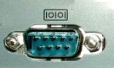Most newer computers have replaced serial ports with much faster and more compatible USB ports

Serial port

**Parallel port:**

* This interface is found on the back of older PCs and is used for connecting external devices such as printers or a scanners.
* Parallel ports can send or receive a byte (8-bit) at a time.
* It uses a 25-pin connector (DB-25) and is rather large compared to most new interfaces.
* 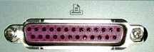Sometimes also referred to as a printer port because the printer is the device most commonly attached to the parallel port.

Parallel port

**USB port:**

* Stands for "Universal Serial Bus." USB is the most common type of computer port used in today's computers.
* It can be used to connect keyboards, muse, game controllers, printers, scanners, digital cameras, and removable media drives, just to name a few.
* With the help of a few USB hubs, you can connect up to 127 peripherals to a single USB port and use them all at once (though that would require quite a bit of dexterity).
* USB is also faster than older ports, such as serial and parallel ports. The USB 1.1 specification supports data transfer rates of up to 12Mb/sec and USB 2.0 has a maximum transfer rate of 480 Mbps.

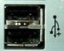

USB port

**AGP (Accelerated Graphics Port) port:**

* AGP is a type of expansion slot designed specifically for [graphics cards](http://www.techterms.com/definition/videocard).
* Since the AGP interface provides a dedicated [bus](http://www.techterms.com/definition/bus) for graphics data, AGP cards are able to render graphics faster than comparable PCI graphics cards.
* Like PCI slots, AGP slots are built into a computer's [motherboard](http://www.techterms.com/definition/motherboard).
* 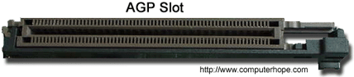It can only be used for graphics cards.

**LAN port (Ethernet port):**

* It allows a computer to connect to a network using a wired connection.
* LAN port looks like for a network cable using an RJ-45 connector.
* The two led lights will blink when that port is active and receiving activity.

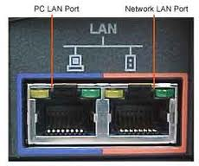

LAN port

**PS/2 connector:**

* PS/2 is a type of [port](http://www.techterms.com/definition/port) used by older computers for connecting [input devices](http://www.techterms.com/definition/inputdevice) such as [keyboards](http://www.techterms.com/definition/keyboard) and muse.
* The port was introduced with IBM's Personal System/2 computer in 1987 (which was abbreviated "PS/2").
* The PS/2 port has six pins and is roughly circular in shape.
* Since each PS/2 port is designed to accept a specific [input](http://www.techterms.com/definition/input), the keyboard and mouse connections are typically color-coded.
* For example, the keyboard port on the back of the computer is often purple, while the mouse port is usually green.

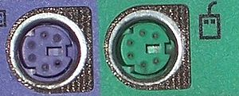

PS/2 Port

**VGA Port:**

* Stands for "Video Graphics Array." It is the standard monitor or display interface used in most PCs.
* The VGA standard was originally developed by IBM in 1987 and allowed for a display resolution of 640x480 pixels.
* The most common is Super VGA (SVGA), which allows for resolutions greater than 640x480, such as 800x600 or 1024x768.
* 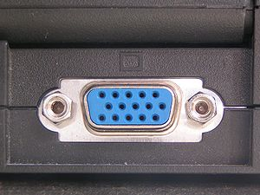A standard VGA connection has 15 pins and is shaped like a trapezoid.

VGA port

**power supply:**

* A power supply is a hardware [component](http://www.techterms.com/definition/component) that supplies power to an electrical device.
* It receives power from an electrical outlet and converts the current from AC (alternating current) to DC (direct current), which is what the computer requires.
* It also regulates the voltage to an adequate amount, which allows the computer to run smoothly without overheating.
* The power supplies an integral part of any computer and must function correctly for the rest of the components to work.
* Since the power supply is the first place an electronic device receives electricity, it is also the most vulnerable to power surges and spikes.
* Therefore, power supplies are designed to handle fluctuations in electrical current and still provide a regulated or consistent power output.

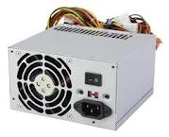

Power supply

**Terminals:**

* The word "terminal" comes from early computer systems that were used to send commands to other computers.
* Terminals often consist of just a keyboard and monitor, with a connection to another computer.
* The purpose of a terminal is not to process information (like a typical computer), but to send commands to another system.
* For example, a network administrator may use a terminal to log in to a network and manage devices connected to the network.
* With modern computers, the word "terminal" usually refers to a terminal program, or emulator, which provides a text-based interface for typing commands.

**Types of text terminals:**

* The System console is a text terminal used to operate a computer.
* Modern computers have a built-in keyboard and display for the console.
* 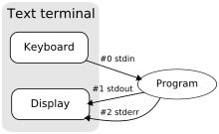Some Unix-like operating systems such as Linux, FreeBSD and Mac OS X have virtual consoles to provide several text terminals on a single computer.

**Connectors**

* 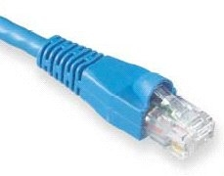**CAT5 NETWORK CABLE** - This cable allows the computer to communicate to other computers over a network. It also provides networked computers access to the Internet

* **MONITOR CABLE** - This cable is usually permanently connected to a monitor. Small screws hold the cable in place.

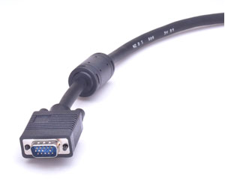

* **USB CABLE -** Most PC's now have these fast and versatile ports on the front and back. They can be used for portable storage devices, digital cameras, scanners, video cameras, printers, keyboards and mice - just about everything!

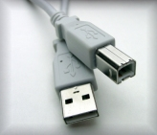

* **POWER CORD** - This is a standard "kettle cord" that connects the computer to the AC outlet on the wall and the power supply of the computer. This MUST be unplugged if you are ever doing any maintenance work inside the computer.

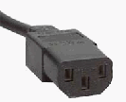

* **PRINTER CABLE** - This is a 25-pin “D” shaped connector that connects printers to the parallel port on a computer. (Newer printers may connect with a USB plug.)

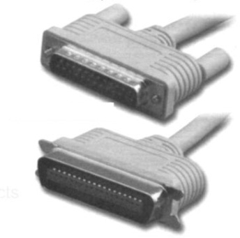

* **PS2 CABLE** - On most computers these days, this connection is used for both the Mouse and the keyboard. This plug has 6 pins-

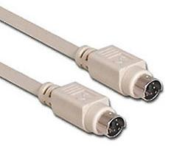

**VGA CABLE** – This is use to connect the monitor to the VGA port.

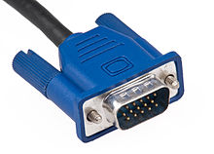

**AUDIO CABLE** – This is use to connect the speaker to the Audio port.

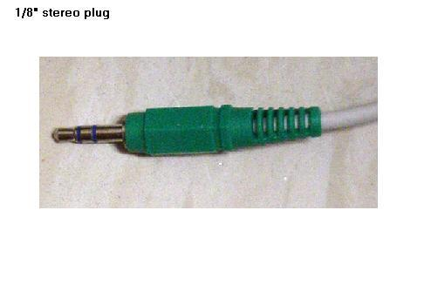

|  |  |
| --- | --- |
| **Information Sheet 2** | **Confirm Client Requirements** |

***System development life cycle***

* To determine appropriate hardware peripheral devices needed within an organization, it is important to clearly understand what your client needs.
* Often clients don’t have a clear idea of what they want.
* Working out clients’ needs requires careful planning and organization.
* The first three stages of the system development life cycle are:

1. Planning
2. Analysing
3. Designing

**Planning:**

* This stage involves identifying the client’s current technology.
* During the planning phase it is necessary to find out information including:
* system specifications
* connections available
* budget constraints
* available timeframe
* Availability of physical space.

A **feasibility study** can be performed to provide a preliminary report to the client about benefits, costs and impact to the organisation. Additionally, a **project request** **form** allows a client to document their initial request.

**System specifications:**

* It is important to find out the specifications of the computer system you are planning to connect the peripheral device to.
* Many newer types of peripheral devices require a specific memory size, CPU speed, Hard disk space, may also compatible with certain operating systems.

**Computer peripherals requirement considerations**

**The processor**:

* Processors are usually differentiated by speed, measured in gigahertz (GHz).
* The higher the GHz, the faster the computer will run.
* But a 3 GHz processor will normally be enough for most business functions.

**The Memory (RAM):**

* Memory is used by the processor to run programs.
* The more RAM your computer has, the more data can be loaded from the hard drive into the RAM, which can effectively speed up your computer.
* In fact, adding RAM can be more beneficial to your computer's performance than upgrading the [CPU](http://www.techterms.com/definition/cpu).
* *For a 3 GHz processor, for example, you should have around 2-3 gigabytes (GB) of RAM.*

**The hard disk:**

* Is used to store the data you create in your business, as well as the programs you use.
* Its capacity is much greater than the RAM.
* An office computer with a 3 GHz processor should have at least 200 GB of hard disk space.

External plug-ins, such as **rewritable DVD, DVD-Read Only Memory (ROM), or CD-RW (rewritable) drives** can be used to supplement your computer's memory.

**The monitor:**

* Liquid Crystal Display (LCD) is lower power consumption, relative to cathode ray tube (CRT) monitor.
* Monitors are normally measured diagonally in inches - typically 19, 22 or 24.
* Larger or wide-screen monitors allow you to compare two documents on-screen.

**Display adapter**

* Software requiring a better than average [computer graphics](http://en.wikipedia.org/wiki/Computer_graphics) display, like [graphics editors](http://en.wikipedia.org/wiki/Graphics_software) and high-end [games](http://en.wikipedia.org/wiki/Video_game) .

**Software requirements**

* Software Requirements deal with defining software resource requirements and pre-requisites that need to be installed on a computer to provide optimal functioning of an application.

1. **Plat form**

* In [computing](http://en.wikipedia.org/wiki/Computing), a **platform** describes some sort of framework, either in hardware or software, which allows software to run.
* Typical platforms include a computer's architecture, operating system, or programming languages and their [run time](http://en.wikipedia.org/wiki/Run-time_system) libraries.
* Operating system is one of the first requirements mentioned when defining system requirements (software).

1. **APIs and drivers**

* Software making extensive use of special hardware devices, like high-end [display adapters](http://en.wikipedia.org/wiki/Graphics_processing_unit), needs special [API](http://en.wikipedia.org/wiki/Application_programming_interface) or newer device drivers.
* A good example is [DirectX](http://en.wikipedia.org/wiki/DirectX), which is a collection of APIs for handling tasks related to multimedia, especially game programming, on [Microsoft](http://en.wikipedia.org/wiki/Microsoft) platforms.

**3. Web browser**

* Most [web applications](http://en.wikipedia.org/wiki/Web_application) and software depending heavily on [Internet technologies](http://en.wikipedia.org/wiki/Internet_technologies) make use of the default browser installed on system.
* [Microsoft Internet Explorer](http://en.wikipedia.org/wiki/Microsoft_Internet_Explorer) is a frequent choice of software running on Microsoft Windows, which makes use of [ActiveX](http://en.wikipedia.org/wiki/ActiveX) controls, despite their vulnerabilities.

**Other Requirement**

* Some software also has other requirements for proper performance.
* [Internet connection](http://en.wikipedia.org/wiki/Internet_connection) (type and speed) and [resolution](http://en.wikipedia.org/wiki/Display_resolution) of the display screen are notable examples.

Examples

# Another factor is what operating system are you going to use? Below are the hardware requirements for installing Windows XP and Windows 7:

# Hardware Requirements for Windows 7 system

If you want to run Windows 7 on your PC, here's what it takes:

1 gigahertz (GHz) or faster 32-bit (x86) or 64-bit (x64) processor

1 gigabyte (GB) RAM (32-bit) or 2 GB RAM (64-bit)

16 GB available hard disk space (32-bit) or 20 GB (64-bit)

DirectX 9 graphics device with WDDM 1.0 or higher driver

**Hardware Requirements for Windows XP Home Edition and Windows XP Professional.**

* These are the minimum requirements for basic functionality.
* If you are installing Windows XP over a network, you may need additional available hard-disk space.

**The minimum hardware requirements for Windows XP Home Edition are:**

* Pentium 233-megahertz (MHz) processor or faster (300 MHz is recommended)
* At least 64 megabytes (MB) of RAM (128 MB is recommended)
* At least 1.5 gigabytes (GB) of available space on the hard disk
* CD-ROM or DVD-ROM drive
* Keyboard and a Microsoft Mouse or some other compatible pointing device
* Video adapter and monitor with Super VGA (800 x 600)or higher resolution
* Sound card
* Speakers or headphones
* After you have determined your organization needs, you can now start documenting your hardware needs.
* There were several sites in the net where you can browse and compare the price of the different medium range to high end computer peripherals.
* One by one you can list down the hardware specs for your client. list below will help you in documenting your chosen hardware:
* Processor
* RAM or Memory
* Hard Disk size
* Video Card
* Lan Card
* DVD drive
* Sound Card
* Mouse
* Keyboard
* Monitor
* One deciding factor to consider in buying computer peripherals is the warranty and after sales support service.
* After you have finalized your hardware specifications, you can now forward it to the right person for budget considerations and finally for procurement.

**Budget constraints**

* While planning the connection of hardware peripheral devices, it is important to be aware of the client’s available budget.
* A client needs to determine whether the benefits that will be gained from the peripheral device justify the financial outlay.
* Factors including the organization’s size, the necessity of the peripheral device to the organization, number of people requiring the device, will all contribute to the organization’s allocation of a budget.
* Another cost to consider is ongoing maintenance.

*Example:*

A laser printer, for example, may initially be more expensive to purchase than an inkjet printer. However when you consider that some inkjet cartridges can cost nearly as much as an inkjet printer, it may be more practical to choose a laser printer, where toner costs are more reasonable.

**Available timeframe**

* The time available to complete a task also needs to be considered when identifying client requirements.
* If, for example, a peripheral device is needed urgently, it will be necessary to quickly find out which suppliers can immediately provide the peripheral equipment.

**Physical space restrictions**

* Before considering acquiring any peripheral device, planning needs to be done to work out where and how the peripheral will reside.

The following questions need to be considered:

* What physical space is available to accommodate the device?
* Are power points in a near proximity if the device needs them?
* Will the installation of the device mean other equipment needs to be relocated?
* Could the device cause disruption or impact on the safety of users?

**Feasibility study**